# **Applied Machine Learning: Ensemble Learning**

### **Explore ensemble learning**

Selecting transcript lines in this section will navigate to timestamp in the video

- [Derek] The amount of data being generated today is truly mind boggling. On average, we create 2.5 quintillion bytes of data every single day. To put that in perspective, that's 2.5 million terabytes or 2.5 billion gigabytes. Think about all the patterns and signal in that data that are just waiting to be uncovered. If you've taken any of my other applied machine learning courses that cover the foundations, algorithms, and feature engineering, you'll understand how to harness messy data, find signal in it, and build models on top of it to make powerful predictions. One of the most commonly used classes of machine learning algorithms are called ensemble learners. This class of algorithms cleverly aggregates a collection of many small, simple models into one extremely powerful model capable of making incredibly accurate predictions. In this course, we'll quickly review some basics, like what an end-to-end machine learning pipeline looks like before diving deep into ensemble learning. We'll cover topics like the underlying theory that drives ensemble learners, what a few examples of ensemble learners look like in Python, and then we'll learn how to actually implement ensemble learning models. We'll cap off this course by evaluating a few different ensemble learners against each other on a real machine learning problem. Hi, I'm Derek Jedamski, a data scientist with a passion for machine learning. Welcome to my course on Ensemble Learning.

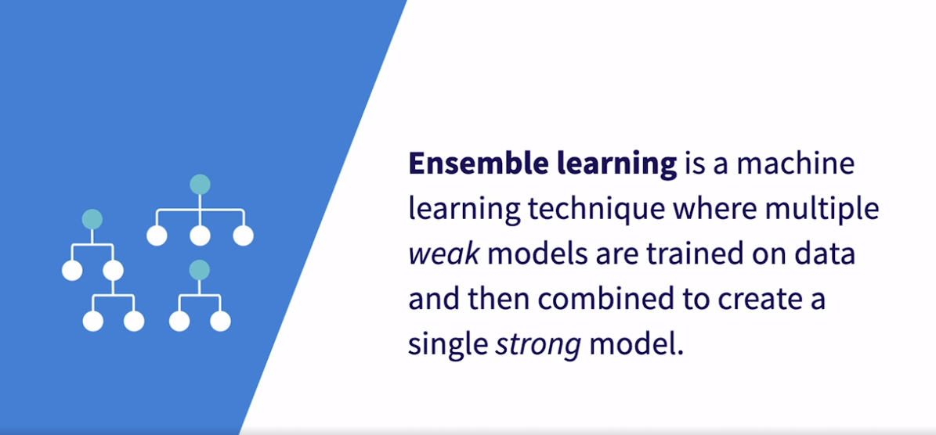

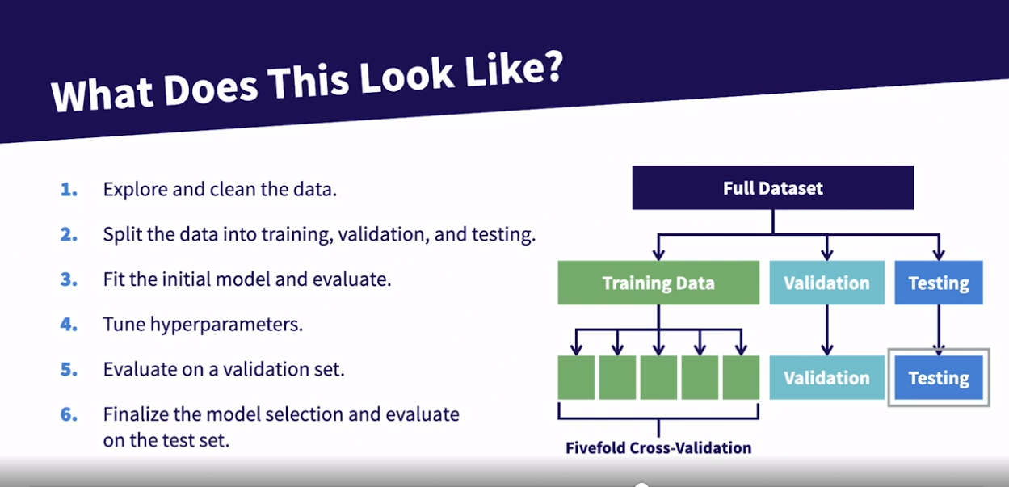

### **What tools you need**

Selecting transcript lines in this section will navigate to timestamp in the video

- [Instructor] Before diving into the course, we want to make sure that you're set up with all the tools and the software you'll need to follow along. I'll be working with Python version 3.8, Jupyter Notebooks and Anaconda version 2021.05. If you haven't used Jupyter Notebooks before, it's a fantastic tool that allows you to combine live code, explanatory text, visualizations and equations all in one concise package. Luckily, everything you need for this course, that's Python version 3.8, Jupyter Notebooks and all the packages you'll need can be acquired very easily by installing the free Anaconda distribution. It's really important to understand that if you're not using the same Python version or the same Anaconda distribution version, there's no guarantee that your code will run the same as mine does throughout this course. So if you do want to use packages you already have installed on your machine just know that any errors you run into are likely due to package version mismatches, which can usually be fixed relatively easily. Now, just to cover our bases, if you're doing your own exploration and want to install additional packages that Anaconda does not have, which are few and far between, just follow the instructions here to install additional packages. Anaconda makes it very easy. From the command line or the Anaconda prompt, just enter conda install and then your package name. Or if you want a specific version, just enter conda install package name equals and then the version you want. Or an alternative is to use pip. The syntax is just the same. It's just a different package manager. So either one of these commands will work to install any package that you need. One last general note, if you're having any issues installing Anaconda, launching Jupyter Notebooks or installing packages, the Anaconda distribution's quite good. Those docs likely contain the solution to any problem you may be facing. Great, now you have all the tools you need to go through this course and even start exploring on your own.

### **Using the exercise files**

Selecting transcript lines in this section will navigate to timestamp in the video

- [Narrator] I've included some exercise files for this course so you can follow along yourself and I highly recommend you do so. Particularly when it comes to learning through code, there's no substitute for actually writing the code and debugging it yourself. So I highly encourage you to use the notebooks, write the code, tweak the code, and see how it changes things. Even purposely break the code so you understand the bounds and why it may or may not work. The exercise files are organized into folders, one for each chapter. Each chapter folder is organized into folders for each individual video. And within each video, you'll notice that there's a begin, and this is a notebook you should start coding in, and an end. This is the completed notebook just for reference. You'll notice each Jupyter notebook is titled with the chapter number, then an underscore, and then the video number. So here you'll find the notebook for chapter six, video five. We're only using one data set for this entire course so you'll find that data set included as well. And lastly, you'll find an empty models directory that will be saving some of our models out to throughout this course. So let's go ahead and launch one of these Jupyter notebooks. So we'll jump over to the terminal and then navigate to wherever you have your notebook stored, and then enter the jupyter notebook command. Then it'll launch Jupyter notebooks right in your browser. And once that is launched in your browser, then you can click through the file structure that we just covered. I will know if you're using a Windows machine, you'll need to launch the Anaconda prompt to open Jupyter notebooks. So now that you know what tools are required, and how to use them, let's get started.

### **What is machine learning?**

Selecting transcript lines in this section will navigate to timestamp in the video

- [Instructor] Let's start with a seemingly elementary question, what is machine learning? Let's start at the origin. **This definition comes from Arthur Samuel. Samuels recognizes one of the first real machine learning pioneers. And he was actually the first to coin the term machine learning back in 1959. He defined machine learning as the field of study that gives computers the ability to learn without being explicitly programmed.** This is a decent definition, but it's kind of vague. And I think it glosses over a couple of really key concepts. **This is how I like to define it. Machine learning is fitting a function to examples and using that function to generalize and make predictions about new examples. This hits on the fact that the algorithm or machine learning model is based on data that you feed it, that's how it learns from examples. And then, the entire goal is to use that learned model to make predictions about new examples.** And this is a really key concept. In other words, machine learning models learn from trends in past data then, they try to find those trends in future data to make predictions. If you think about it, we all do this on a daily basis. We learn from our past experiences to adjust our behavior, or our views in the future. With that definition in mind, an even simpler definition of machine learning is just pattern matching. Again, a model takes in a bunch of data. Then, it starts to learn how to organize all the information it extracts from the data fed to it. Then, it learns a pattern and it fits a function to it. Then, uses that function to pick up on these patterns in future data to make a prediction about it. So something like a fraud detection model for a credit card company model learns what conditions typically indicate a fraudulent charge based on the past data. Then, when it's presented with a new charge that fits those conditions it can predict that the charge is fraudulent. Let's look at a really, really simple example of machine learning. So that would be a simple single variable linear regression. So this plot is showing the number of umbrellas sold based on the amount of rainfall. So the model seeks to predict how many umbrellas will be sold based on the amount of rainfall. The model in this image is represented by this best fit line. You may remember that the equation for a line is y equals mx plus b, where y is the thing you're trying to predict, or umbrellas sold in this case. x is the thing you're trying to use to predict it, rainfall in this case, m is the slope of your line and b is the y intercept. So m and b are the parameters that you want your model to learn based on the training data to fit a reasonable model to capture this trend. Once it learns m and b based on the data then you'll have an equation for this best fit line and that equation is your model. Remembering back to our definition, fit a function to examples and use that function to generalize and make predictions about new examples. We covered the first part of this, we have a function or a model that is fit to data. Now, what model allows you to do is say that if it happens to rain 110 millimeters, even though I don't have any examples of days where it rained exactly 110 millimeters, I can say that based on my model we could expect about 30 umbrellas to be sold. Again, this is a very simple example. And, typically, the models you'll encounter in your work will be much more complex.

### **What does an end-to-end machine learning pipeline look like?**

Selecting transcript lines in this section will navigate to timestamp in the video

- [Instructor] Each of the four courses in this applied machine learning series is intended to cover a different portion of this end-to-end machine learning pipeline. At the end of this video, I'll describe where each course falls in the pipeline so there's a concrete understanding of where this specific course lies relative to the other courses in this series. With that said, don't worry if you don't have a complete understanding of each of these areas. I'll provide enough context to each stage in this course to get you caught up. For now, let's quickly review the process of building a machine learning model at a very high level. We'll start with a full data set and the first step will be exploring that data to really understand the type of features we have, what they look like and how they relate to the target variable or the thing we're trying to predict. Then we'll use some of those learnings to clean the data. The next step is to split our data into training, validation and test sets to prepare to fit a model and evaluate it on unseen data. Then we'll use something called fivefold cross validation to fit an initial model and see what we can expect for a baseline performance of the model. Then we'll be using fivefold cross validation to explore a variety of different hyperparameter settings for each algorithm. You'll notice later on in this course that we actually fold steps three and four into one step using the GridSearchCV tool in Scikit-learn. Then we'll select a couple of our best models and we'll evaluate them against each other on the validation set. Lastly, we'll select the best model based on the validation set performance. And we'll evaluate it on a test set to get a completely unbiased view of how we can expect this model to perform on unseen data. We'll be running through all these steps a little later on in the course, but as I mentioned, I'll provide enough context so you don't have to necessarily take the other courses but we will be covering those steps very quickly. So if you're new to machine learning and want an overview of the entire process and want to gather the foundational knowledge that you need to really apply to any machine learning problem, I would strongly encourage you to take applied machine learning, the foundations. If you really just want to deep dive on the first step where we explore and clean the data, applied machine learning feature engineering focuses on that process of really extracting every last ounce of value out of your data. Applied machine learning, the algorithms, focuses on the process of fitting initial models, tuning hyperparameters, optimizing the model, and then evaluating the final outcome. That course covers a few different types of algorithms and would be a good place to start if you want to better understand the broad set of machine learning algorithms. This course is actually going to live in same space as the algorithms course and we're just going to deep dive into a specific class of algorithms called ensemble learners. Now that we've defined machine learning, looked at a few examples in real life and zoomed in to take a look at what a full machine learning pipeline looks like, let's take a quick aside in the next video to talk about a critical element in all of machine learning but especially in understanding ensemble learners and that's the bias-variance trade off.

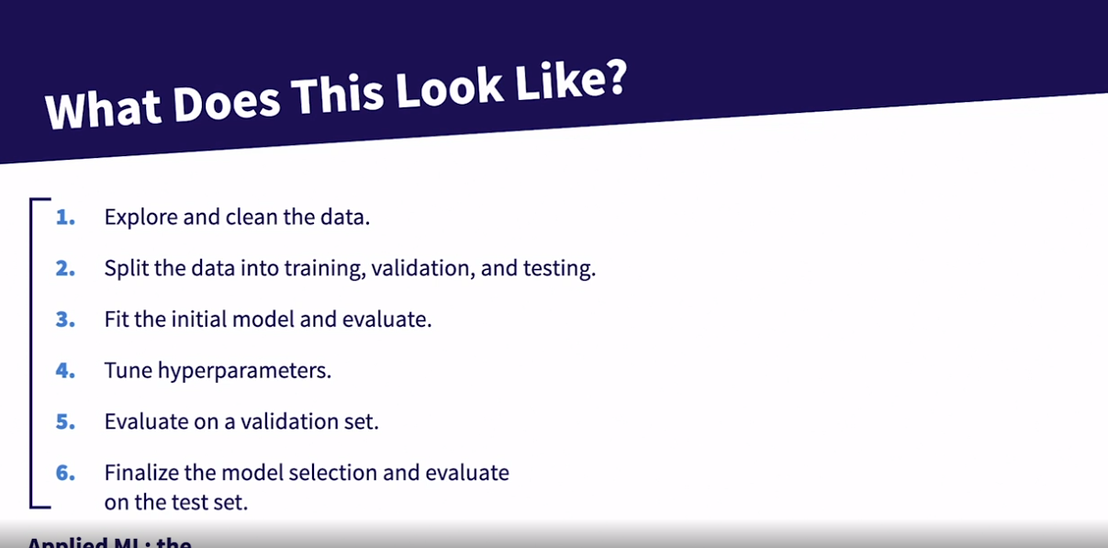

### **Bias-Variance trade-off**

Selecting transcript lines in this section will navigate to timestamp in the video

- [Instructor] You can't discuss the power of ensemble learners without discussing the bias variance trade off. So let's take a step back and dig into what that actually means. We're going to use a dartboard analogy because it offers a nice visualization of what bias and variance represent. We're going to start at the top left here and we'll rotate around clockwise. So in the top left what we see is low bias and low variance. That means that you're centered on the bullseye, and you are consistently hitting that bullseye. This is what it would look like for a pro dart player. Rotating to the top right, this is low bias but high variance. That means you're centered around the bullseye, you're not consistently actually hitting it. So breaking this apart, low bias dictates that you're centered around the bullseye, high variance dictates that you're spread out and not consistently hitting whatever you're aiming for, the bullseye in this case. So this would be a fairly good dart player, but not quite good enough to consistently hit the bullseye. Now rotating to high bias and high variance in the bottom right. This means you're not centered around the bullseye and you're spread out. This is probably what it looks like when I'm playing darts. Finally, the bottom left is high bias and low variance. This means you're not centered around the bullseye, but the darts are fairly concentrated. This would either be somebody that's confused about what they should be aiming for, or maybe it's a pro dart player that's just aiming for triple 20 or something other than the bullseye. So let's formally define these terms and then we'll shift into what it means to achieve the right trade off between these two. Bias in machine learning is the algorithm's tendency to consistently learn the wrong thing by not taking into account all of the information in the data. High bias is a result of the algorithm missing the relevant relationships between features and the target variable. Using our dart analogy, we're missing the bullseye. The model doesn't really understand what it should be aiming for. And as a result, its predictions are consistently off base in a systematic way. Okay, now looking at variance. This has to do with the algorithm's sensitivity to small fluctuations in the training data. High variance is a result of the algorithm fitting to random noise in the training data. This is otherwise known as overfitting. In our dart analogy, high variance means our dart throws are extremely imprecise. One throw could hit the bullseye and the next could miss the board entirely. This means a model is very, very highly tuned to the data that it's seen already. Perhaps just memorizing the examples it's seen. So it can absolutely nail predictions for example that look identical to what it's seen before, but it does very poorly on examples that look nothing like what it's seen before. Now, don't worry about understanding the ins and the outs of this plot right now. We'll look at it a few times throughout this course. What I do want you to see in this plot is that model complexity is along the X axis. So we have complex on the right and simple on the left. And then model error is on the Y axis. Now we have this teal line that we represents the variance, and that consistently increases as the model gets more complex. So more complexity means higher variance. Then we have this red line that represents bias, and bias decreases as the model gets more complex. So less complexity means high bias. Lastly, we have total error, which is very high for both the very simple model and the very complex model. It bottoms out somewhere in the middle where you'll see that vertical line that says optimum model complexity. So this is what the bias variance trade off is all about, finding the right complexity of the model that minimizes both variance and bias as much as possible. If you only focus on minimizing bias, then you'll have high variance. If you only focus on minimizing variance, then you'll have high bias. The goal is to find the appropriate trade off of bias and variance to reduce the overall error as much as possible. Let's make this a little more concrete by tying this to what a decision boundary may look like for a two dimensional model where we're trying to separate Xs and OS. So a very simple model would just be a straight line across. You could see that it's likely not picking up on the true trends in the data. This is high bias, low variance. And we refer to this model as being underfit because it's not finding the real trends in the data. On the other extreme, a very complex model would create a decision boundary that is fitting too closely to the training data. So this decision boundary likely is not picking up the real trends in the data either. It's just overfitting to the training data. And it's likely to be too sensitive to small fluctuations in the data. This is an overly complex, low bias, high variance model that we would call overfit because it's too closely fit to the training data. Then somewhere in the middle, we have a decision boundary that fits to the real trends in the data without overfitting to every X and O in the training data. This model's going to be low bias and low variance. Now just a attaching these to the original plot we were looking at. We can pull together what we mean by the bias variance trade off. As we make the model more complex, we're reducing the bias, but increasing the variance. Our goal is to find the right balance between the two for the optimal model. This will be useful to understand as we dive deeper into ensemble learning throughout this course.

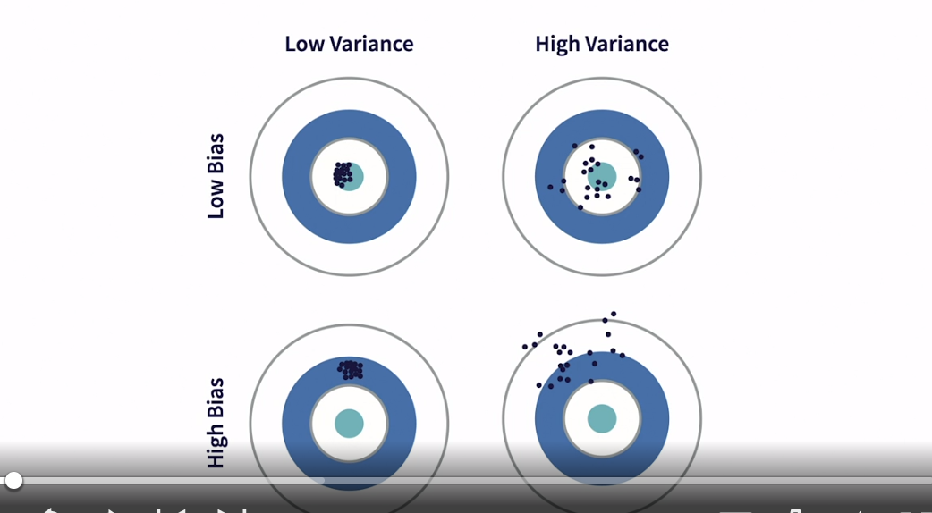

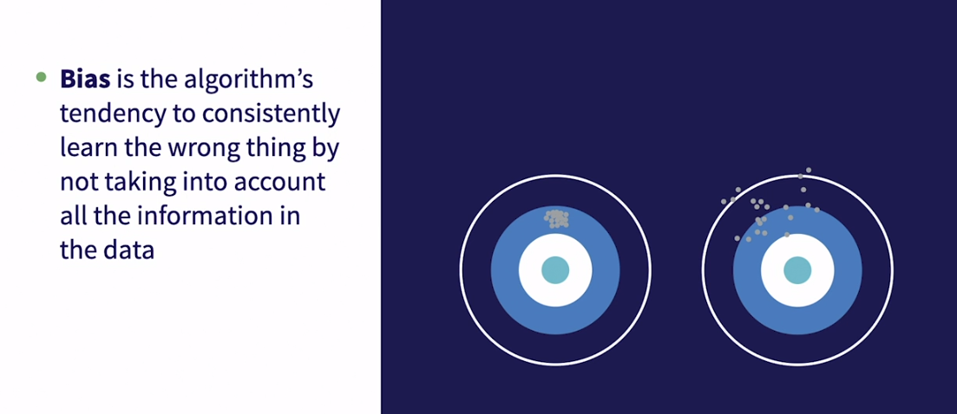

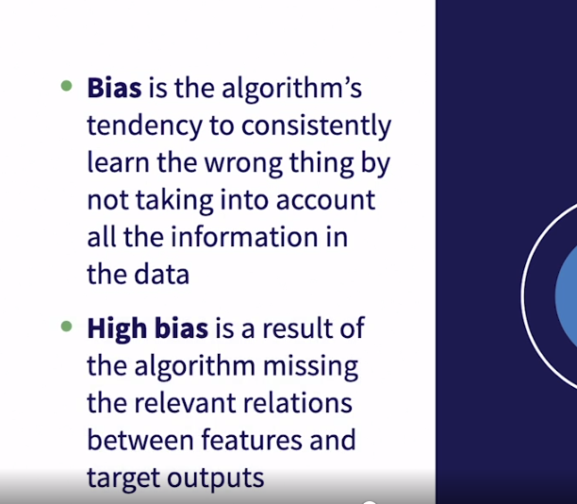

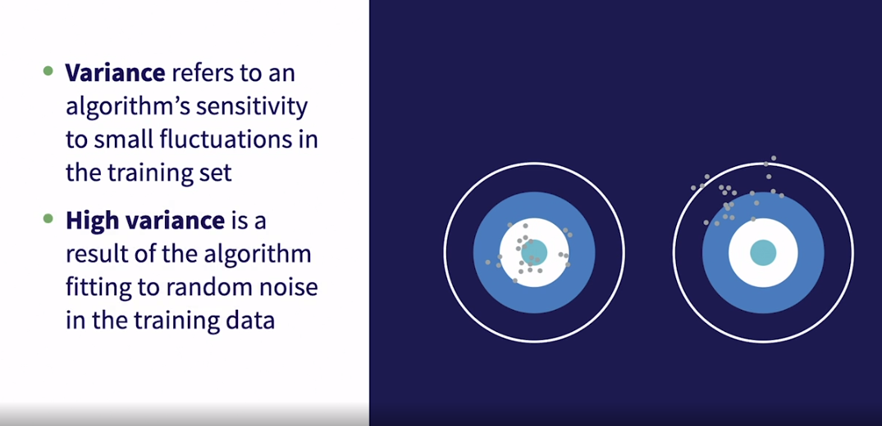

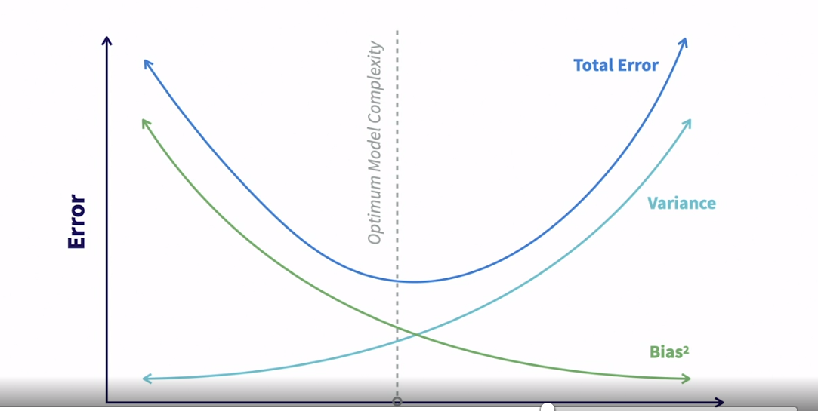

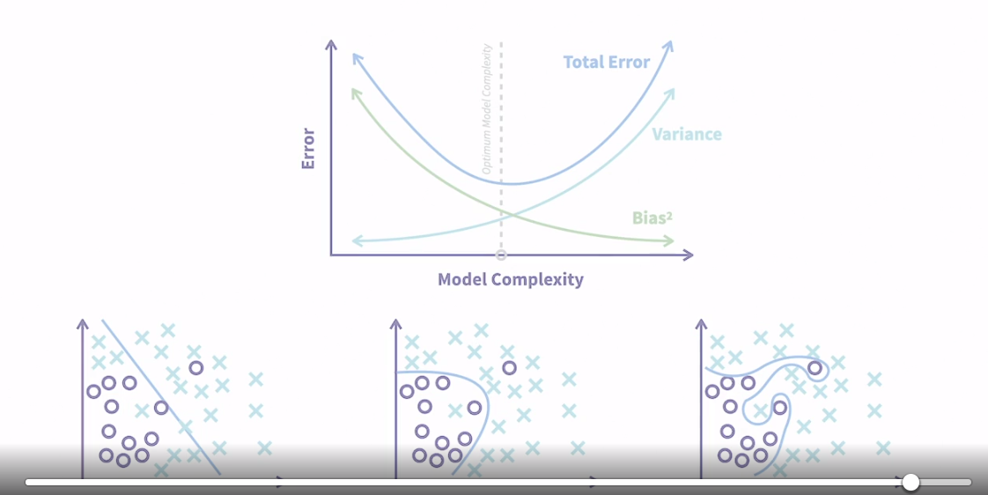

## **Question 1 of 4**

What is an example of machine learning?

* linear regression  
  Correct
* memory allocation
* summation

## **Question 2 of 4**

Through collaborative filtering, a machine learning recommendation system finds that Bob and Tom are similar. If Bob enjoys pizza, salad, and soda, and Tom enjoys pizza and salad, what should the system recommend?

* something that both Bob and Tom tried before  
  Incorrect
* a soda for Tom
* something that both Bob and Tom never tried before  
  Incorrect



Replay

Review this video

What does machine learning look like in real life?

3m 13s

## **Question 3 of 4**

Using the dartboard analogy, how would you describe high bias combined with low variance?

* a widely scattered cluster of dots centered at the bullseye
* a tight-knit cluster of dots centered far away from the bullseye  
  Correct
* a tight-knit cluster of dots centered at the bullseye

## **Question 4 of 4**

When examining the machine learning pipeline sequence, at what point do you split the data into training, validation, and testing bins?

* after you tune the hyperparameters
* after exploring and cleaning the data  
  Correct
* after you fit the initial model on the data

### **Reading in the data**

Selecting transcript lines in this section will navigate to timestamp in the video

- [Instructor] Throughout this course, we're going to learn to implement a few different ensemble learning techniques. And then, at the end of the course, we'll compare the performance of each of them against each other. In order to set up for that, in this chapter we're going to introduce the data that we'll be using, clean it up, and then write out our training validation and test sets to ensure that we're using the same exact data for each model. The dataset we'll be using is this Titanic dataset, which is a publicly available dataset that's commonly used for machine learning. And if you've taken any of my other applied machine learning courses you'll be familiar with this data. It's worth mentioning that we're only using the training set from the Kaggle competition in this course because the target values have been stripped from the test set. We'll need those target values to evaluate our models, so we're just going to take the training set from the Kaggle competition, and then we'll split it into our own training validation and test set. So this dataset contains information about 891 people who were on board the ship when it departed in 1912. Some people aboard the ship were more likely to survive the wreck than others. There weren't enough lifeboats for everybody, so certain groups of people were prioritized. Our task is to build a model to predict which people would survive using certain information about the 891 people aboard. Let's quick walkthrough the features that are available to us in this dataset. So we'll have the name of the passenger, we have their ticket class, the sex of the passenger, their age, the number of siblings and spouses aboard, the number of parents and children aboard with the passenger their ticket number, passenger fare, cabin number and then where they boarded the ship. So let's get into the data. We're going to start by importing pandas, reading in our data, and then taking a look at the first five rows by calling this .head method. So you'll see each of the features that we discussed above. The survive column is the one that we'll be trying to predict, 0 means did not survive, 1 means they did survive. And all the other columns are to be considered as potential features for the model. As I mentioned before, in this section we will be cleaning the data and then writing out our training, validation, and test sets. The main idea behind cleaning the data is that it allows us format or structure the data as well as we possibly can to potentially predict whether a person survived or not. If you're interested in digging more into this topic, feel free to take a look at my Feature Engineering course that is part of this Applied Machine Learning series. In the next video, we'll dive into cleaning up this data.

### **Cleaning up continuous features**

Selecting transcript lines in this section will navigate to timestamp in the video

- [Instructor] In this video, we're going to quickly clean up the continuous features and in the next video, we'll clean up the categorical features. Once again, we're doing a very quick pass over this aspect just to get the data in better shape to fit a model. So we're going to start by reading in our full dataset just like we did last time but we're going to import a few additional packages that will help us clean up all of our data and visualize that data. So let's run this cell and just print out the first five rows again and we'll see all these features that we covered in our last video. So let's get into the cleaning. The first step is going to be filling in the missing values for the age feature. Now, we're going to call this isnull and sum command, which will essentially just count up all of the missing values for each feature in our data. You could see that there are 177 missing values for age. If you explore this data, you'll find that it's missing at random. You'll also notice that there are missing values for cabin and embarked and we'll handle those in the next lesson, since they're categorical features. So let's fill in these missing values for age. Since they're missing at random, we want to just replace it with a value that won't sway the model one way or the other since missing age doesn't really mean anything in itself. So we're going to replace the missing values by calling this fillna method on the Age column and what we need to do is just tell it what to replace those missing values with. So we'll take this Age column and we're going to tell it to replace the missing values with the mean value of age across the full dataset. And then the last thing we need to pass is this inplace=True argument to tell Python to alter titanic as it stands now without requiring a new data frame to be created. And then let's just print out the first 10 rows of this dataset and you'll see for the age column that these are all integers, except for this 29.699118 and that's a replacement for the missing value. So now that we have age cleaned up, let's move on to the next feature to clean up. Based on the definition of SibSp, and Parch, we know that both have to do with family size. One is the number of siblings and spouses and the other is the number of parents and children. I'm going to quickly print out these categorical plots that will show the average survival rate by different values of these features. What we're doing here in this cell is we're looping through these two features, telling matplotlib to create a new plot for each. Then we're calling the catplot method from Seaborn and telling it to create a point plot using the titanic dataset and the survived column and then whichever column we have from this loop. So let's run this cell. The vertical line that you'll see in these plots basically an error bar that corresponds to the sample size at each level. So a larger bar means a smaller sample size. The key thing that you want to notice here is that for both features, they have the same response to the survival rate. In other words, as you have more siblings and spouses, or more parents and children, you are less likely to survive. Since these features are so closely related, let's go ahead and combine them into one feature. So combining them is really as simple as just adding the two columns together and storing it as a family count feature name. So we'll assign Family_cnt and we'll copy that and we'll set it equal to SibSp plus Parch. Then we can run that cell and now we have a new feature created in our dataset that is the sum of SibSp and Parch. Now, the last thing that we'll do for the continuous features is we need to drop the two features that we just created, this Family_cnt feature out of. The reason is that the value these two features are providing are now going to be captured by this Family_cnt feature. So they effectively become redundant and if we leave them all in there together, it could create some multi-collinearity issues. Additionally, we're going to drop the passenger ID feature because it's an identifier with no distinguishing power on whether somebody survived or not. So all we need to do to drop them is call this drop method and then we're going to pass in a list of the features that we want to drop. So PassengerId, SibSp, and Parch. And then we just need to indicate that we want to drop on axis equals one and then alter the titanic data frame inplace. And then let's go ahead and print out the first five rows again. And we'll run both of those cells. So now you could see that we have a Family_cnt feature while SibSp, Parch and PassengerId are now all gone. Now we could see there's still some categorical features that need to be cleaned up and we'll address that in the next lesson.

### **Cleaning up categorical features**

Selecting transcript lines in this section will navigate to timestamp in the video

- [Instructor] In this video, we'll continue the cleaning we started in the last video, but now we'll focus on the categorical features. Just a reminder, if you're picking this up as a new notebook you'll need to rerun the prior cells, to ensure that you have the appropriate data and packages for the code that we'll be covering. Let's start by creating an indicator for the cabin feature. As a quick reminder, running this isnull sum method to count the missings, we see that cabin is missing for 687 people in this data set. Recall for age, we simply replaced the missing values with the average value for age, we're able to take that approach because age was missing at random, so we couldn't really bake any information into that missing value. It's not the same in this case, and let's see why. Let's take a quick look at survival rate, based on whether cabin is missing in this data set or not. We'll do that by calling this group by method on the titanic data set, then we just needed to tell it what to group on, and we'll tell it to group on the cabin feature, and whether that cabin feature is missing or not. Then we need to tell it what to return. We'll tell it to return the mean value of the survived column for each of these two groups. So we could see that survival rate is drastically lower when cabin is missing, which is indicated by true here. So that would lead us to believe that cabin was not missing at random. In fact, maybe it meant that these people actually didn't have a cabin, as a result, maybe they were sleeping somewhere in the ship that made it very difficult for them to escape. Regardless of the reason, we want to make sure that we can capture this information in a way that we encode this variable. So we're going to do that by creating a really simple cabin indicator to tell us whether the given passenger had a cabin or not. We're going to do that using the where method from numpy, that essentially acts as an if statement. So we're going to assign that to a new feature called Cabin_ind and then we just need to tell it that if logic to execute on. So tell it to execute on, whether the cabin feature is missing or not, and we'll tell if cabin is missing, then return is zero, and if cabin is not missing, then return a one. And lastly, let's just print out the first five rows. And now we can see wherever cabin is missing, it's a zero, and wherever cabin is present, Cabin_ind is a one. So let's move on to the next feature that we're going to clean up. Next feature we're going to clean up is we're going to convert the sex feature from male versus female to numeric. The reason we do this is because a model doesn't need to know what male versus female really means. It just needs to know that there are two different values for sex. What those values are, doesn't really matter. So if we convert it to being numeric it just makes it a little easier for most models to handle. So we have a dictionary that does this sex to numeric mapping, now we just need to apply that to the sex column and we're going to use this map method in pandas. So in order to map it to this column we're going to call the sex column, and then we're going to call .map, And then we'll tell it just to use this dictionary to do the mapping for us, and we're actually going to store that back as the sex column, we don't need to create a new column for this. And then lastly, just as we always do let's print out the first five rows, and now we could see for our Sex column instead of being male versus female it's zeros and ones. Now, the last thing we need to do is just drop unnecessary variables in order to clean up our data. Now that we have cabin indicator, we don't really need the raw cabin feature because it becomes redundant. Name and ticket are both identifiers, but they don't really have any determining power on whether somebody survived or not. The only remaining feature that we're dropping that we haven't discussed yet is this embarked feature. If you explore this data set you'll find that there are different survival rates with the levels of the embarked feature. However, it's not really a causal relationship. What you'll find is that different percent of people boarding at each port were women, and different percent of people boarding at each port had cabins. So sex and cabin indicator are the real causal features here, not the embarked feature. So we're going to drop this feature as well, but if you want to better understand that relationship and why we're doing this, feel free to take a look at my Feature Engineering course, which dives into this specific aspect of the data a little more deeply. So we already have our drop command coded and we'll just call the first five rows. And now we can see that we have an nice clean data set without any irrelevant or repetitive features and without any missing values. So the last thing we need to do is just write out our clean data set, so we can pick it up in the next video and split it into training validation and test sets.

### **Write out all train, validation, and test sets**

Selecting transcript lines in this section will navigate to timestamp in the video

- [Instructor] In this video, we're going to split up our full data set. So we have 60% of our examples in the training set, 20% in the validation set and 20% in the test set. Doing this kind of split will help us evaluate the models and perform model selection using unbiased results. Let's start by importing the packages we'll need and read in our data. So we're going to this train test split method imported from Scikit-learn and this is going to make our job here very easy. I also want to call out that we're reading in this Titanic cleaned dataset that we created in the last video. So let's run that cell and get into splitting up our data. We're going to start by splitting our data into our features by dropping the survive column and our labels or our target variable, which in our case is whether somebody survived or not. Then we're going to call the train test split method and the first thing we need to do is pass in our features, then we'll pass in our labels. And now this is a good point to call out the ideally we would want to split features and labels into three separate data set sets, training tests, and validation. Unfortunately, this train test split method can only handle splitting one dataset into two. So effectively, we're going to do our split in two passes through this train test split method. On our first pass, we're going to tell it to allocate 40% of the data to the test set. And we do that by calling test size equal to 0.4 and that will leave 60% of the data to the training set. Then we're going to run train test split again after this where we'll take that 40% allocated to the test set and we'll effectively split it in half. And that will leave us with 60% in the training set, 20% in the validation set and 20% on the test set. So focusing on this first pass through, the last argument we have to set is called random state. And this is just the initialization seed for the randomizer. So we'll just set that to 42 and it's important to note that the ordering the output is critical. It will first take the features and split it into two, so that will be x train and x test and then it will take the labels and split it in two and then it'll be y train and y test. So this will give us 60% in our training set and another 40% in the test set. So we're going to do our second pass through this now. So let's copy this line and then we're going to change this test size to 50% because we want to take the 40% that is left here and split it in half. So that will give us 20% in the validation set and 20% in the test set. Now we just need to update the names here. So what we want to on a split is the x test, which is our features in the test set and y test, which is our labels for the test set. And then we just need to update the output to x underscore val and y underscore val. So once again our first pass through it's going to take a full data set and allocate 60% to our training data and leave 40% for the test data. Then we're going to take the test data and pass it through train test split again and we're going to split it in half so that we have half in the validation set and half in the test set. So we can run that and now let's run a quick check to make sure that 60% actually went to the training set and 20% each to test and validation. So what we're going to do is we're going to create a loop, so we'll say for dataset in, will loop through our training, our validation and our test sets. And then each iteration, we're going to print out the length of the dataset, divided by the length of the labels. So the data set here is represented by whether it's y train, y validation or y test and labels represents the length of our entire full data set that we allocated up here. Last thing we're going to do, we're just going to round this to two decimal places, so here we could see just as we would expect, y train makes up 60%, y val makes up 20% and y test makes up the other 20%. Now the last thing we need to do is write these all out, to make sure we're using the same exact training validation and test sets as we're exploring our different on ensemble learning techniques. So we'll use this two CSV method to write out our data frames to CSV files just like we did in the last video. And we're going to include this index equals false argument here, so that Pandas doesn't write out the index as a new column in the CSV file. So we can run that cell and now our data is all set up so we can pick it up to how to implement these ensemble learning techniques.

## **Question 1 of 3**

How can you modify the ages of passengers in a dataframe without requiring a new dataframe to be made?

* titanic['Age'].fillna(titanic['Age'].mean(), inplace=True)
* Correct
* titanic['Age'].fillna(titanic['Age'].mean(), self=True)
* titanic['Age'].fillna(titanic['Age'].mean(), df=True)

## **Question 2 of 3**

How can you remove unnecessary variables inside the titanic dataframe?

* titanic.drop(['Cabin', 'Embarked', 'Name', 'Ticket'], axis=1, inplace=True)
* Correct
* titanic.remove(['Cabin', 'Embarked', 'Name', 'Ticket'], axis=1, inplace=True)
* titanic.delete(['Cabin', 'Embarked', 'Name', 'Ticket'], axis=1, inplace=True)

## **Question 3 of 3**

Lesedi has a new data set called titanic that she wants to explore using pandas. What command lets her see the first five rows of the data set?

* titanic.read(5)
* titanic.display()
* titanic.head()
* Correct

### **What is ensemble learning?**

Selecting transcript lines in this section will navigate to timestamp in the video

- [Instructor] In this chapter, we're going to talk about what ensemble learning is at a very high level. This will provide the foundation and the motivation to dig into three types of ensemble learning techniques that we'll discuss later on. Let's start with some simple definitions first. Ensemble learning is a machine learning technique where multiple weak models are trained on data and then combined to create a single strong model. This is intentionally vague as the definition needs to remain broad enough to apply to a few different techniques that all fall under the umbrella of ensemble learning. Learning the degree to which these base models are weak varies by ensemble learning technique. So some techniques require these base models to be weak, and others don't necessarily. The overarching takeaway here, though, is the goal is not necessarily to make these base models as powerful as possible. The value really is brought through the second layer strong model that aggregates the output of all of the base models. So what do we mean by weak model and strong model? A weak model is one that is not strongly correlated with the target variable. Simply put, it's not a great model. It's only slightly better than random guessing. A strong model is one that's very strongly correlated with the true outcome or the target. Now one question that might up is why not just train a strong model right off the bat? Well, that comes down to the bias variance trade-off that we discussed previously and how ensemble learning techniques optimize that trade-off in a way that is difficult to achieve with just a single strong model. Just keep that in the back of your mind. We're going to dig deeper into that topic as we move forward in this course. This course will cover three of the most common techniques that fall under the umbrella of ensemble learning. The first is called boosting. This is an ensemble technique where each weak model is learned sequentially rather than in parallel because often each weak learner depends on the previous one. Then these predictions are combined via some averaging or voting process, depending on the problem. Bagging is an ensemble technique where each weak model is learned independently and often in parallel. Then predictions are combined in some deterministic way, again often via some averaging or summing. Boosting and bagging are quite similar in many ways, including the fact that they typically combine homogeneous weak models, meaning that when using boosting or bagging, you're not usually combining weak models trained by a variety of different types of models. In other words, you won't usually be combining logistic regression, SVM, random forest. All of your weak models will typically be of the same type. The main difference between boosting and bagging that you need to be concerned with at this stage is just remembering that in bagging, the weak models are learned independent of each other, while in boosting, the weak models are learned sequentially and are not independent of each other. The last type of ensemble learning that we'll cover in this course is called stacking. Stacking is an ensemble technique where each weak model is learned independently, just like in bagging, but then the output of these weak models are fed into a metamodel that you train on top of the output of your weak models to generate the final output. Beyond the fact that stacking leverages a separate trained model to generate final predictions compared to boosting and bagging where the strong model outputs are usually just based on averaging or voting, stacking often combines heterogeneous weak models. So we said that usually all weak models will be of the same type for boosting and bagging. That is not the case for stacking. So for stacking, one of the weak models could be logistic regression, maybe the next is random forest, and so on. Then these are all combined by one metamodel to generate final output. With some basic definitions out of the way, in the next video, we'll dive deeper into how this actually works under the hood.

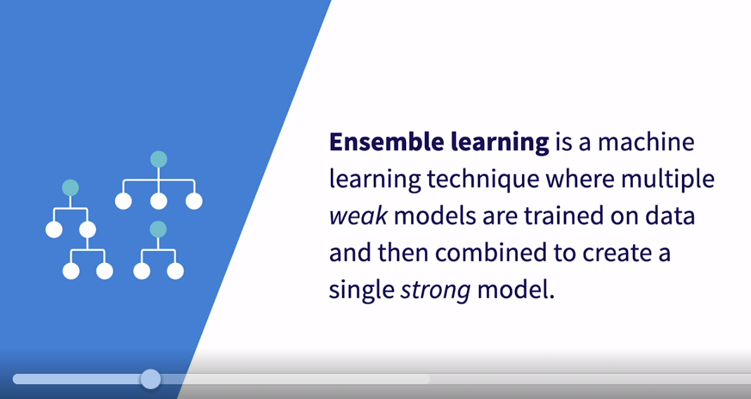

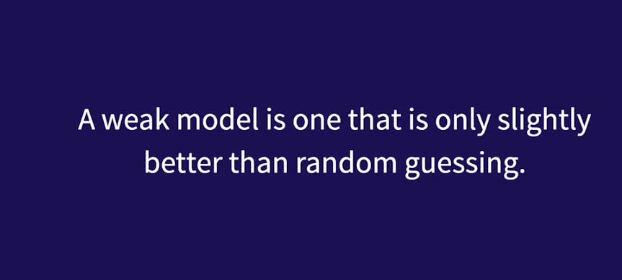

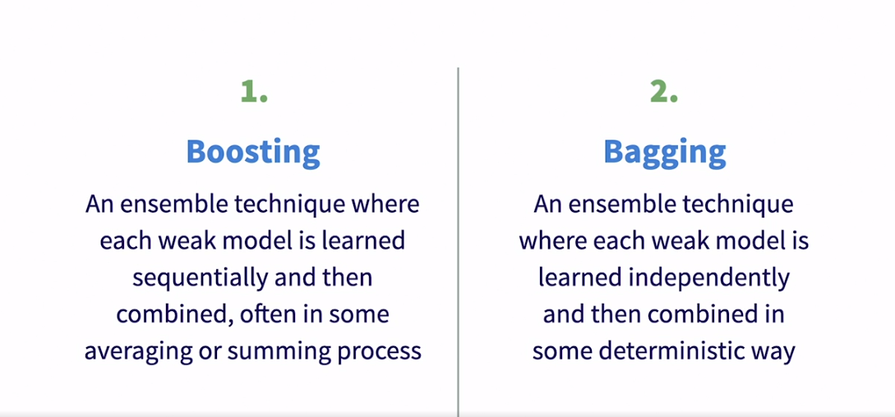

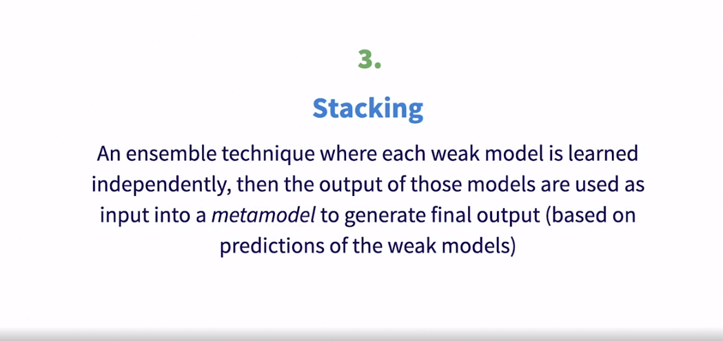

### **How does ensemble learning work?**

Selecting transcript lines in this section will navigate to timestamp in the video

- [Instructor] With some basic definitions out of the way and before diving into more details about how these techniques actually work, let's look at a very high level general diagram of what this ensemble learning framework looks like. Again, this very general to allow it to apply to all three techniques we'll be discussing in this course. So we start with our training data and we'll train N models on it. So you could train three models on it, or you could train 300 models on it. And that's part of the model optimization process, deciding how many weak models or base models to train. And it's important to note this level is what we call our weak learners or weak models. Now, two things to call out here about the differences between our techniques at this stage. The first is remember for bagging and boosting, all of these weak models will usually be of the same type. And often they'll all be decision trees. For stacking, these models are often different types. So one could be logistic regression, the next random forest, and so on. The second difference between our techniques that we haven't discussed yet is regarding the data fed into these models to train them. The data always comes from the training data but the sampling technique differs between boosting, bagging, and stacking. We'll cover how that sampling works when we dive deeper into each technique. So each of these weak models are trained and then they'll generate some prediction or output. So we'll have one output for each of our N models. The output from these weak models will be fed into some Metamodel. Now we're using the term Metamodel here very loosely in boosting and bagging, often this stage just means average all of our predictions together if it's a regression problem or we count votes effectively for a classification problem. For stacking, this is usually a real model that is trained on the output from all of the weak models. In other words, this Metamodel will learn which of the weak models are useful and which are not and will combine the information in a way that will typically generate output that is very strongly correlated with the true outcome. It's worth noting that sometimes we feed additional data or features into this Metamodel as well. So it would accept the output from the weak learners as well as some additional features. Finally, this Metamodel, whether it's a real model or just averaging or voting, will generate some final output. So again, we're taking training data, we're training N week models on that training data, then we're taking the output of those N week models to generate a final prediction. So this is kind of the 10,000 foot view and you may be asked asking yourself, why don't we just go right to the strong Metamodel? In the next video, we'll start to answer that question by digging into why this type of framework is so powerful.

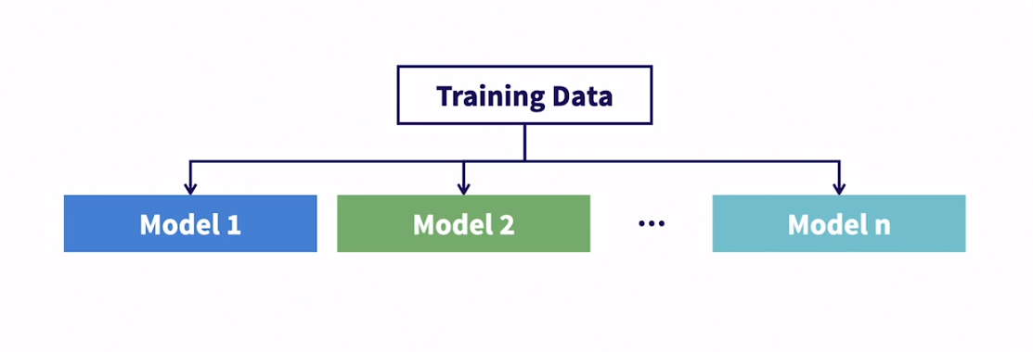

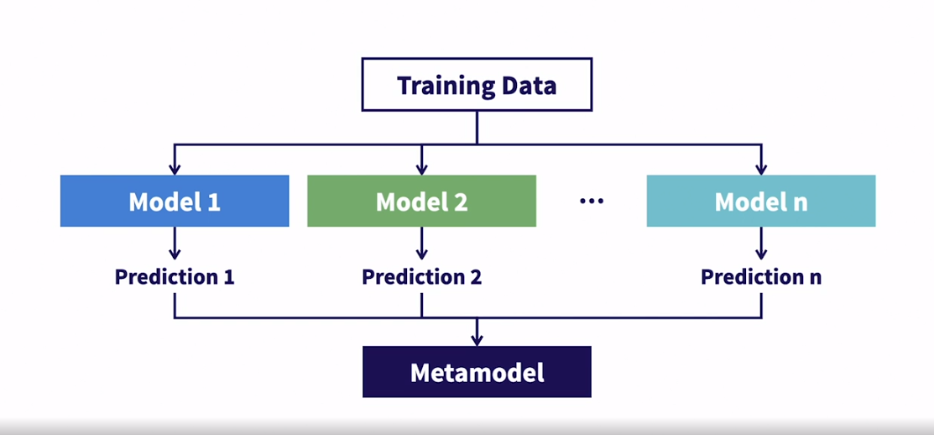

### **Why is ensemble learning so powerful?**

Selecting transcript lines in this section will navigate to timestamp in the video

- [Instructor] Now that we have a general feel for how ensemble learning works, let's talk about why it's as popular as it is. What makes it so powerful? Well, the non-technical answer is that models are a little like people, each one comes with biases and blind spots meaning that they'll perform better in a group where individual biases can be adjusted for and blind spots can be illuminated. People can work together to come to the best answer with all perspectives considered. Some people will pick up on trends or ideas that others may miss. And when you combine all of that insight and all of those perspectives together, it can be really powerful. The more technical answers that ensemble learning reduces bias and variance while limiting the risk of overfiting. Just to copy out that slightly, you can still overfit, but ensemble learning allows you to push the limits a bit more before you reach that point of overfiting. So let's dig into this technical portion a little bit more. Recall this plot from earlier in the course that illustrates the bias for variants trade off. We see that the total error is driven by bias and variance. As bias goes down, variance goes up and we have to find the appropriate tradeoff between the two to reduce total error. Total error is at its highest at the extremes, meaning models with high bias or high variants are weak models. So on the left side of this plot we have a very simple underfit model that has high bias and low variance. On the right side of this plot, we have a complex overfit model that has low bias but high variance. As I mentioned before both of these extremes are weak models. It can be easy to assume that a weak model means a simple model, but that's not necessarily the case. Overfit, complicated models are also considered weak models because their ability to classify new data will be poor. Now pulling in the diagram we went through in the last video. What we're saying here is that each of these weak learners will reside at the extremes of this plot. They'll have high total error caused by either high variance or high bias. The magic of ensemble learning is for a given type of ensemble learning, they'll force all the weak models to either be high bias and low variance, or low bias and high variance. Then in combining the weak models it minimizes whichever aspect of the total error is high. So let's look at boosting first. Boosting requires each weak learner to be incredibly simple and underfit. That means it'll have very low variance which is great, but high bias. The magic of boosting is the way in which it sequentially learns it's able to leverage the low variance from each weak model and drive down the bias by learning from the mistakes of each prior weak model. It's not critical for you to understand the mechanism causing this to happen, we'll be deep diving into that in the next chapter. It's just important to understand that for boosting, combining many weak learners allows us to capture their already low variance and then drive down the bias by the way in which we combine them. Conversely in bagging, we start with very complex, overfit weak models, that have low bias but high variance making the total error high. And then the way in which bagging then combines these weak models, allows it to leverage the low bias and drive the variance down to achieve a lower total error than you would be able to achieve with a single model. Okay, enough speaking in general terms let's start diving deep into each of these ensemble learning techniques, starting with boosting.

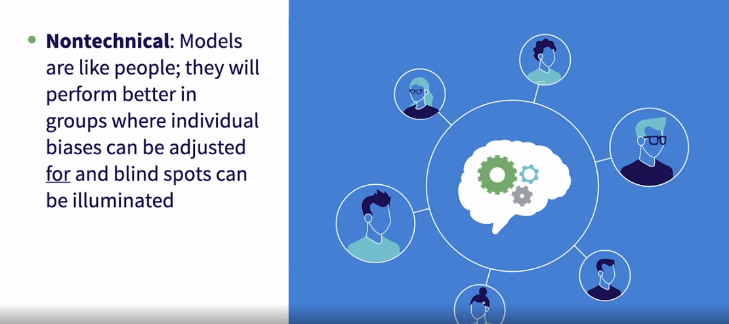

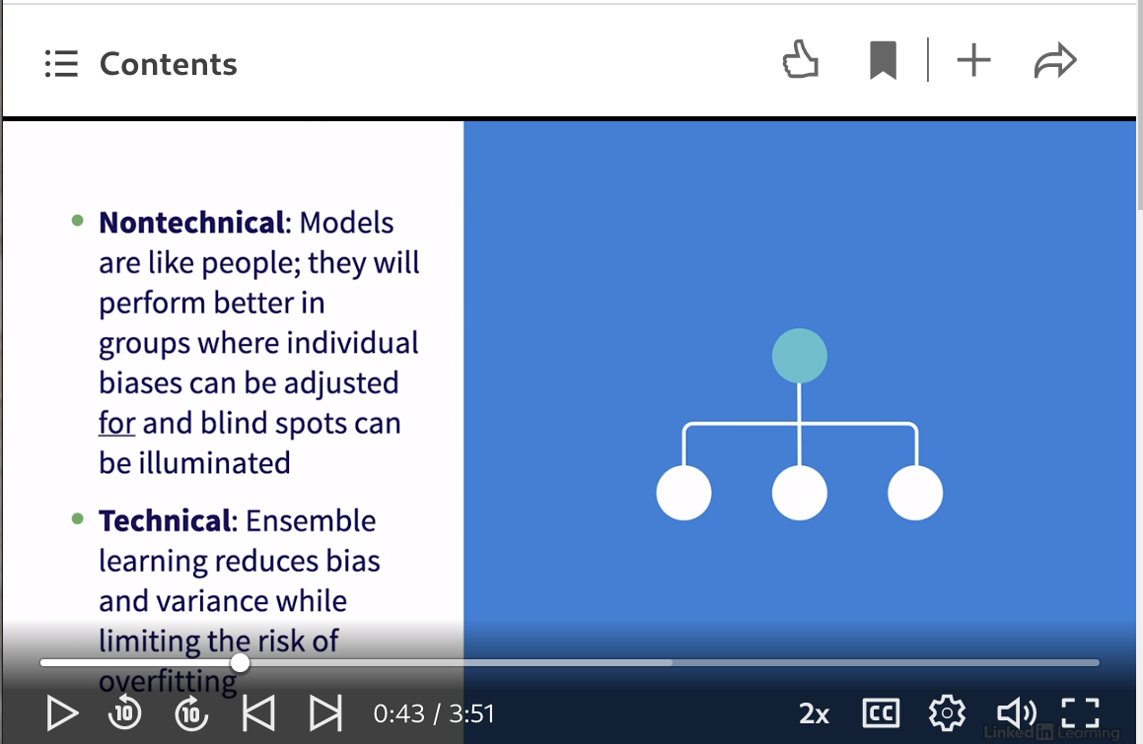

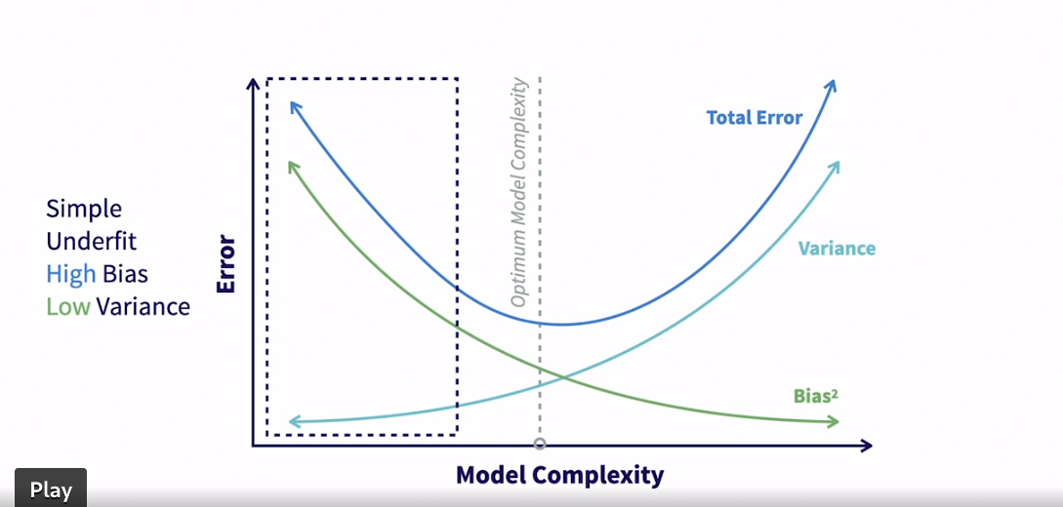

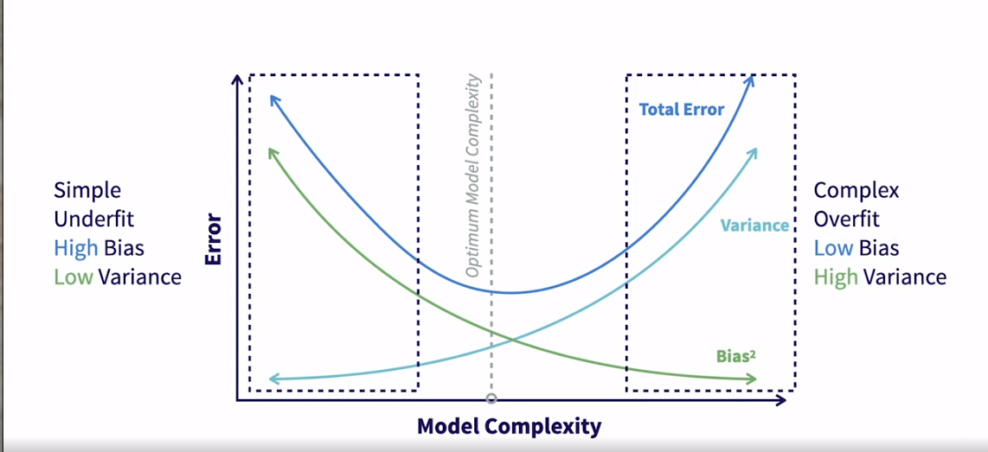

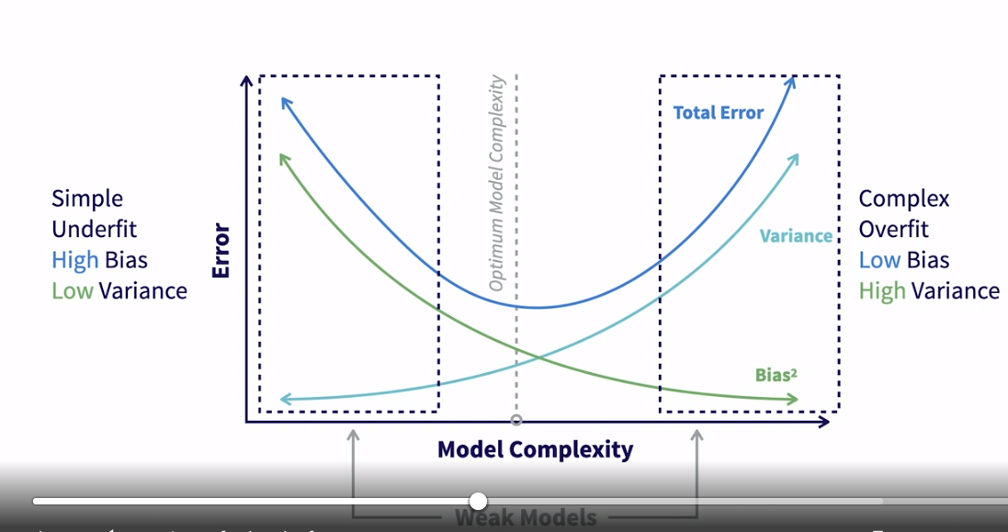

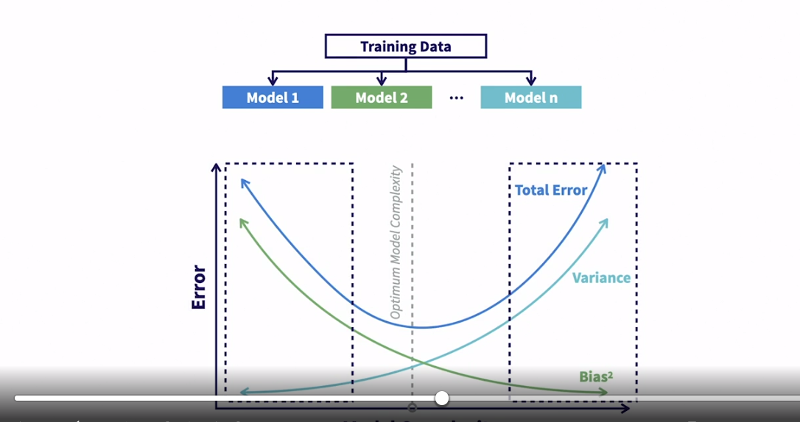

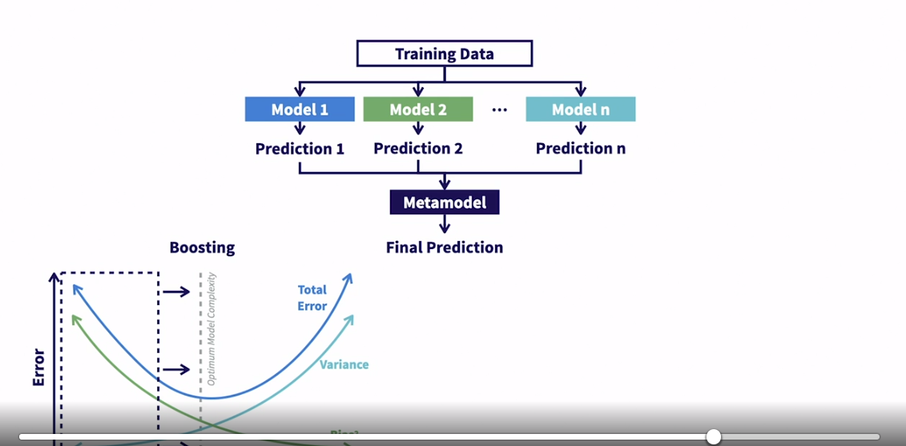

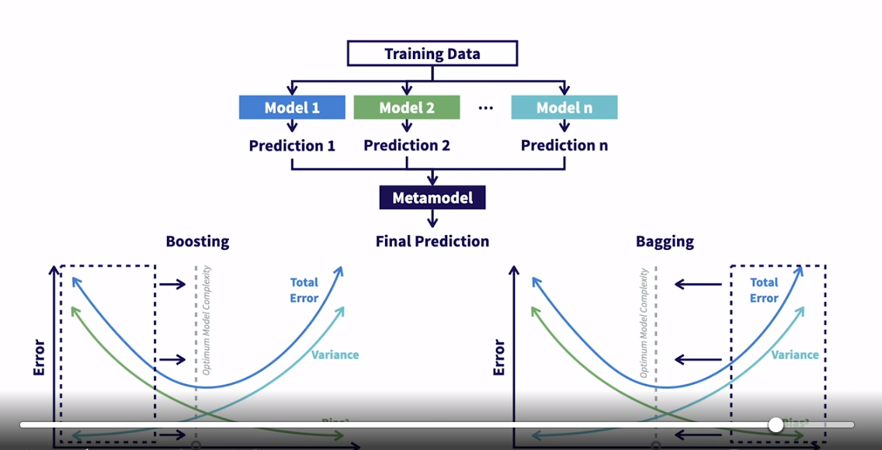

## **Question 1 of 3**

How do you apply the boost ensemble learning technique?

* Learn each weak model sequentially, and then combine them in an averaging or summing process.  
  Correct
* Learn each weak model independently, and then combine them in a deterministic way.
* Learn each weak model independently, and then those outputs are placed into a specially trained metamodel to generate the final output.

## **Question 2 of 3**

What properties does a complex overfit have?

* low bias, low variance, and high total error
* high bias, low variance, and high total error
* low bias, high variance, and high total error  
  Correct

## **Question 3 of 3**

What important item should you note about inputs that can go into a metamodel?

* Additional data and features not originating from any of the weak models can be added to the metamodel.  
  Correct
* Only prediction output from all the weak models can be input into a metamodel.
* Only categorical data can be input into a metamodel.

### **What is stacking?**

Selecting transcript lines in this section will navigate to timestamp in the video

- [Instructor] Now let's talk about the last of the three ensemble techniques that we'll cover in this course. And that's stacking. Stacking is an ensemble method that creates one strong metamodel that's trained on the predictions of several independent base models. On the surface, that may sound awfully similar to boosting and bagging. And the reality is that these are similar since they all fall under the umbrella of ensemble learners. So let's dig into the ways in which stacking is different than both boosting and bagging. The first is that the base models and metamodel are all trained on the same dataset, the full training set. Remember that in boosting and bagging, we use sampling techniques to generate the data for our base models to train on. In part, that's to make sure each model is different from each other and keying in on different trends in the data. We don't need to do that with stacking because the base models can be different algorithms. So instead of sampling the data to allow our base models to find different trends in the data, we use different algorithms altogether, which will naturally find different trends or information in the data. So the idea is that we could have one base model that's logistic regression, one that's random forest and so on and each of those algorithms have certain strengths that will allow them to look at the data in different ways and find different trends. Another difference is that in boosting and bagging, we typically have a large number of base models. In stacking, we usually have far fewer, maybe as few as three or four compared to sometimes hundreds in boosting and bagging. The last difference is that boosting and bagging use very naive metamodels. They usually just do some sort of averaging or voting from the weak models to make the final prediction. Stacking built an actual model on top of the predictions from the base models to generate the final prediction. What this allows is for the metamodel to learn which base model should be prioritized and weighted differently. Sometimes we feed in extra data into the metamodel in addition to the base model predictions. In all, the idea with stacking is using different algorithms for the base models allows each of them to contribute certain unique insights based on the way each algorithm is optimized, then the metamodel can learn on top of those unique insights to understand which models should be leaned on for the final prediction. This creates quite the powerful framework. Let's look at a visual representation of this framework, but before doing that, let's quickly revisit what the framework for boosting looks like. Again, some things to notice here. These weak models are all trees and they are intentionally very shallow weak trees. The models are all trained on samples from the training data and the models are all trained sequentially based on their need to learn from prior models. Now let's jump to bagging and notice, again, these are all trees as well and these trees are all trained on, again, samples from the training data. Now let's get into what this looks like for stacking. So we start with the full training set and then we train end models on top of that training set. Again, these can all be different algorithms so the first could be logistic regression and then random forest and so on. So each of these models generate a prediction. It's worth calling out here that while these models are all trained on the same exact data, they can and will generate different predictions on individual examples because models are not deterministic. You can train the same exact algorithm on the same exact data and get two slightly different answers. In addition to that, if using different algorithms for these base models, each algorithm will handle the data in different ways, optimize in different ways and so on, leading to different answers in some cases. Then we would take all those predictions and feed them into a metamodel. It's worth noting that sometimes there will be some supplemental data that is fed into the metamodel on top of the predictions from the base models. This really just depends on the problem and whether the base models are fully able to capture all of the information required to make accurate predictions. Then finally, the metamodel is trained to generate a final prediction. This creates a really powerful framework where the base models can twist and turn the training data to look at it in different ways, then we can combine all the outputs of those models into a single model that can learn how to weight those insights in making a final prediction.

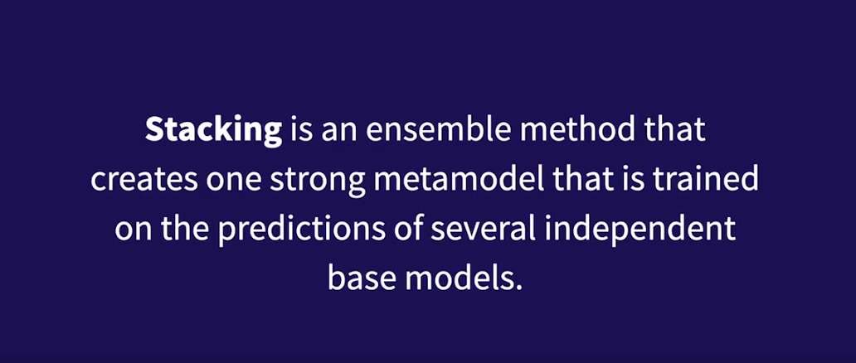

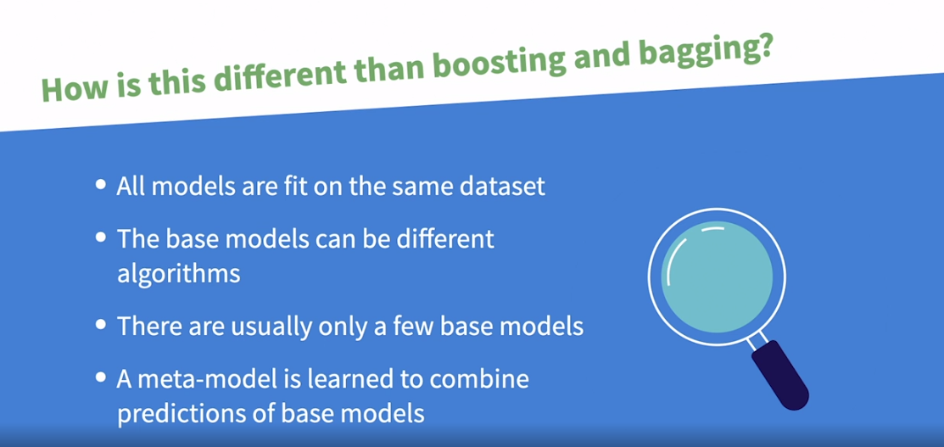

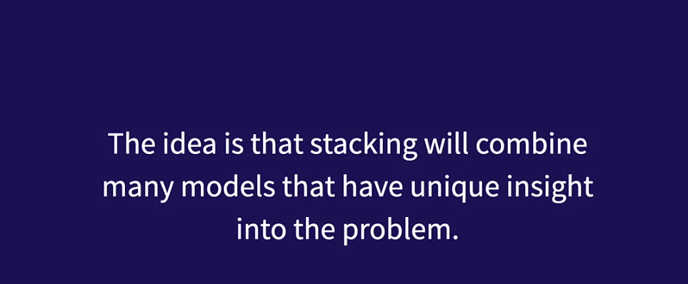

**Boosting**

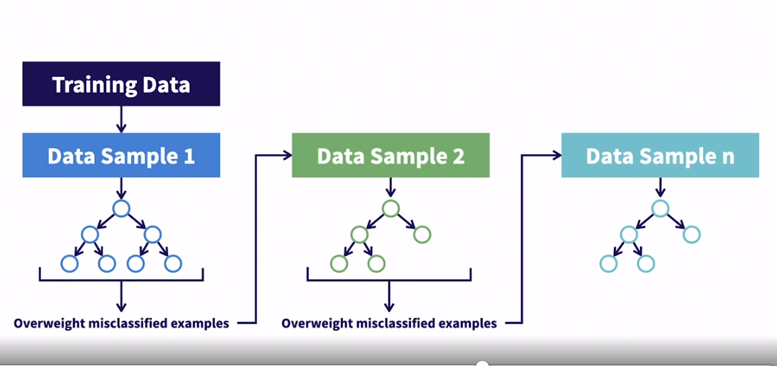

Bagging

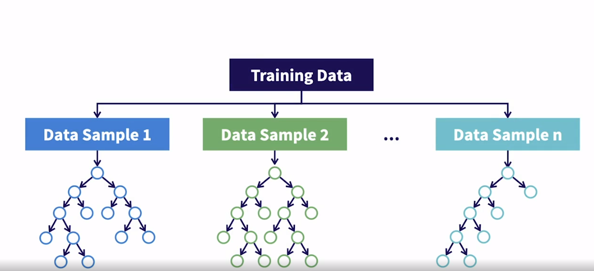

Stacking

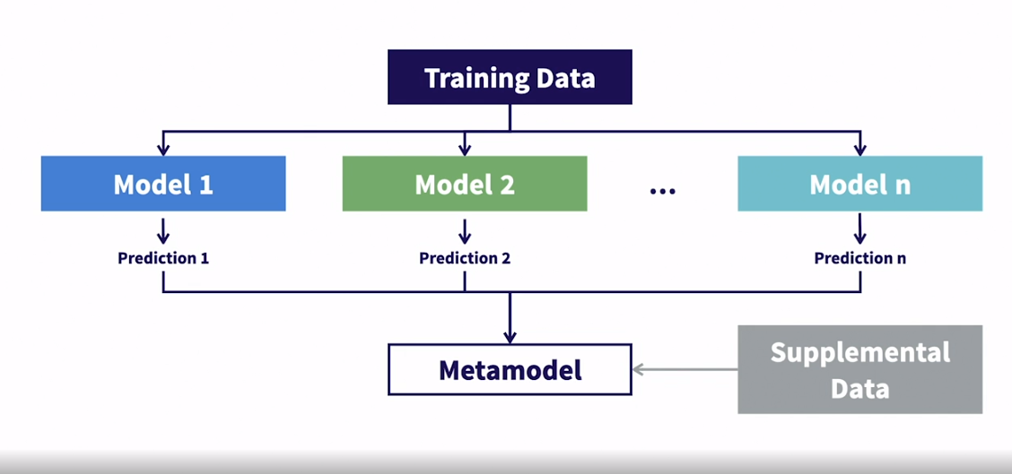

### **How does stacking reduce overall error?**

Selecting transcript lines in this section will navigate to timestamp in the video

- [Instructor] Let's dig into how stacking reduces overall error. Just a reminder, boosting starts on the left side of this plot with simple under fit based models with high bias and low variants. Then the process of boosting drives down the bias to achieve the optimal bias variants trade off. Bagging starts on the right side of this plot with more complex over fit models with low bias and high variants. Then the process of bagging drives down the variants to achieve the optimal bias variants trade off. The way stacking reduces error is essentially the same as how bagging reduces error. We have complex base models and we reduce the variance by giving them all a voice and combining them to a meta model. Let's revisit the diagram from last video in order to better understand how stacking reduces error. Again, we'll be moving through this quickly since it's essentially the same as bagging. So we've trained N complex models on the training set and all of these models represent our weak models where the total error is driven by the high variance. Then just like with bagging, stacking reduces the variance by taking all these complex high variance models and simply giving them each a voice. Remember high variance means the models are most likely overfit to the training data. And because we use different algorithms from our base models, they're all different and likely overfit to different things in our training data. So by giving each a voice and allowing the meta model to learn which models to rely on for which information, it reduces the variance because the metamodel is not overfit to the training data in the way that our base models were. Stacking is a powerful tool that allows you to dig deep into the data and extract as much value as possible without overfitting. In the next lesson, we'll talk about when you should use stacking and when you should not use stacking.

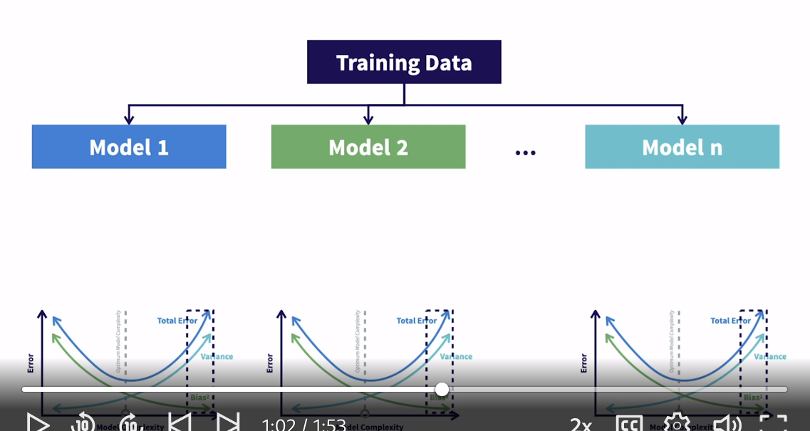

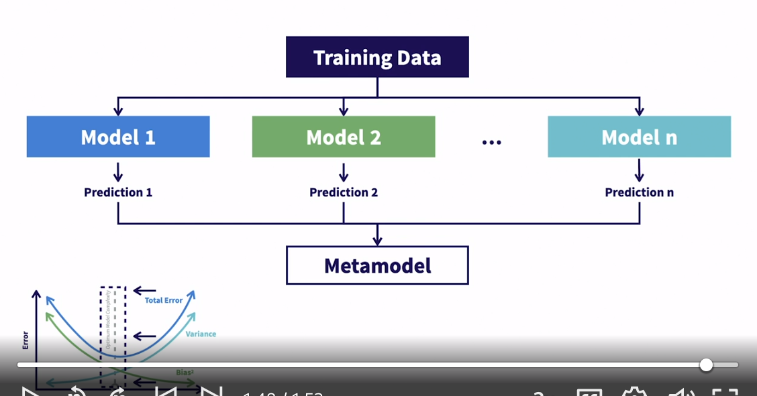

### **When should you consider using stacking?**

Selecting transcript lines in this section will navigate to timestamp in the video

- [Instructor] In this video, we're going to talk about when you should and should not use stacking. Just like we saw with the other two methods, stacking works quite well for problems with both categorical and continuous target variables. If you have a very complex, novel problem that you're trying to solve with really nuanced, complicated data, then stacking might be a good option for you because you can tailor it so much to the problem that you're trying to solve and you can allow different algorithms to try to extract out the complicated trends in the data to solve the problem. This is actually the main reason that you would use stacking. It's not terribly easy or fast to implement but it can be really powerful. On that note, let's talk about a few instances when you should not use stacking. You should not use stacking if you're looking for a quick benchmark model. We talked about bagging being a good option for a benchmark model because it's quick to implement and train and it's flexible in handling different data types. Implementing stacking can be a time-consuming process as you're training and evaluating many different types of models. Consider looking elsewhere if you need a quick benchmark model. Just like boosting and bagging, stacking is also a black box algorithm. If transparency is important, if you want to be able to easily explain the model and the decisions it's making, you shouldn't use stacking. As previously mentioned, it's really complicated. It can be difficult explaining the choices made even by a single model. Let alone a bunch of models combined together with a new model train on top of all those models. If transparency is important, look to one of the other tools you have. Lastly, stack models can take a long time to train and it can take a long time to make predictions with as well. That's because you're training so many complicated models and then training a new model on top of those models as opposed to simple averaging or voting like we saw with both boosting and bagging. So if you need fast training or prediction, you may want to consider other options. Stacking is a tremendously powerful technique but should really only be used to solve very complex problems where all you care about is the performance of the model, regardless of how transparent it is or how long it takes to train.

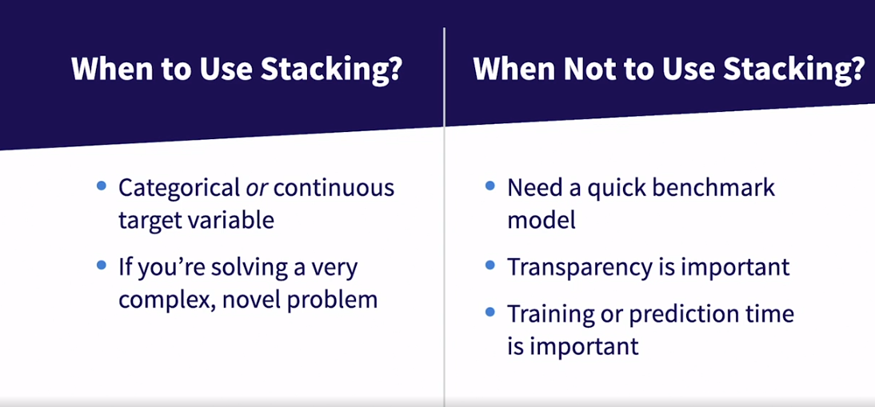

### **What are examples of algorithms that use stacking?**

Selecting transcript lines in this section will navigate to timestamp in the video

- [Instructor] So let's talk about algorithms you can use that leverage stacking. For boosting, we talked about gradient boosting and adaptive boosting as two algorithms that leverage boosting. These two algorithms implement the sampling technique that allows the weak models to learn from the mistakes of the prior models. For bagging, we talked about random forest as the most popular algorithm that leverages bagging. Random forest implements the data and the feature sampling required. So for both boosting and bagging, there are sampling techniques that are unique to those tools that require an algorithm to execute the overall process. For stacking, it's a little bit different. There's not necessarily any sampling or training that is unique to stacking. Stacking is much more general. It's just a framework where we set up our models in a certain way to extract as much value out of the data as possible. So there's not really a known algorithm like gradient boosting or random forest that implement stacking. With that said, implementing stacking manually can be quite time consuming, since you have to train end models and then aggregate predictions to train a metamodel on it. For that reason, there is a tool in scikit-learn that helps you set up your stacked framework. That **tool is called StackingClassifier in the ensemble package from scikit-learn. There's also a StackingRegressor tool if you're working on a regression problem.** So instead of talking about the specifics of a given algorithm like we did for boosting and bagging, we're going to talk about some of the parameters that'll be passed into StackingClassifier. And we're going to highlight what those parameters are that you'll pass into StackingClassifier by referring to the stacking diagram that we reviewed earlier in this chapter. The first parameter that you'll pass in is called estimators. And this is a list of algorithms you want to use for all of your base models. So you could pass in say, logistic regression, random forest, and gradient boosting, and then the StackingClassifier object would then train one logistic regression model on the training data, one random forest model on the training data, and one gradient boosting model on the training data. So if you want three models, you pass in a list of three algorithms. If you want five models, you pass in a list of five algorithms. So now that you have your base model set, now you have to define the algorithm you want to use for your metamodel. And you do that with an argument called final estimator. This is the algorithm that will be used to train the metamodel on the predictions from the base models. The default here is logistic regression. Lastly, there's an argument called passthrough, which is just a boolean to indicate whether you want to train the model on only the base model predictions, or if you want to also pass through some supplemental data from the training set. Now, those are not the only parameters in StackingClassifier but they are the main parameters that you'll need to know if constructing a stacked model in Python using scikit-learn's StackingClassifier. This context will be useful in the next few videos, as we move towards implementing an actual stacked model.

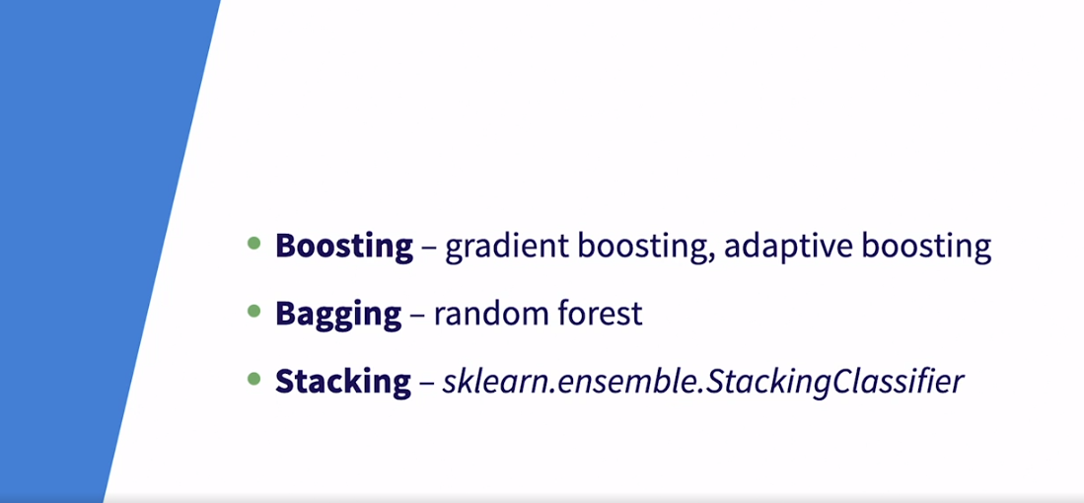

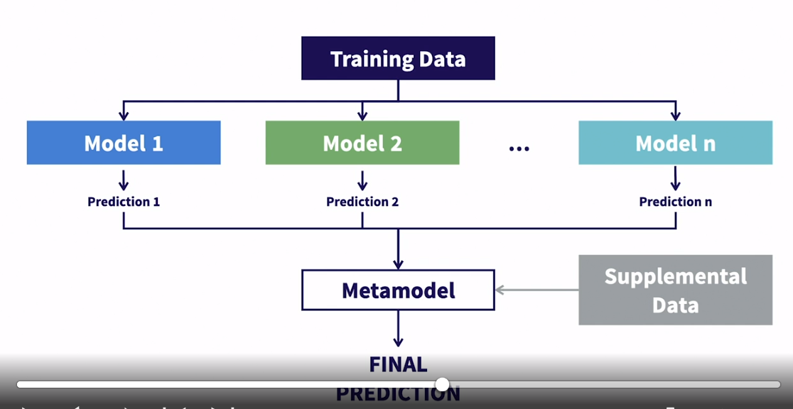

### **Explore stacking algorithms in Python**

Selecting transcript lines in this section will navigate to timestamp in the video

- [Instructor] Just as we did for boosting and bagging previously, in this video we'll explore some of the key hyperparameters for the StackingClassifier in Scikit-learn. Let's start by importing the StackingClassifier from sklearn.ensemble, and here you'll see one difference between this algorithm and the others we've looked at previously. So let's try to call the parameters in the same way we did with prior models by calling this get_params method. You'll see, we get an error here that basically says it expects an estimators argument to be passed into StackingClassifier. The GradientBoosting and RandomForest classifiers had no such requirements. Recall from the last video, the estimators argument is a list of algorithms to use for the base models. You can check out the docs linked above if you want to read more about this argument. So let's pass in a list containing the two algorithms that we've already looked at earlier in this course. So first we're going to need to import the GradientBoostingClassifier and RandomForestClassifier. GradientBoosting and RandomForest. Then we're going to define a list of estimators and what this list actually is, is a list of tuples. The first entry in the tuple will be what you want to name the model. And the second entry will be the actual algorithm. So let's start with GradientBoosting and we'll just name it gb like we did in prior chapters. Then we need to call the GradientBoostingClassifier and we're going to leave the parentheses open so it'll just use the default settings for each hyperparameter. Then for our next model, we'll use RandomForest and we'll name it rf, and we'll do the same thing. We'll just we'll leave the default hyperparameter settings. Then we just need to add the estimators argument to the StackingClassifier. So copy down estimators, that's the name of the hyperparameter, and we'll tell it we're just passing in a list named estimators. So now we should be able to run this and it'll give us our list of hyperparameter settings. So there's a lot of potential hyperparameters that we could tune here. So let's start at the bottom and work our way up. You'll notice all of these arguments, here at the bottom of the list, begin with the rf prefix. So these are all the hyperparameters for the RandomForest model. So you aren't only tuning hyperparameters for the stacking algorithm, but you're also tuning the hyperparameters for the base models, RandomForest in this case. If you think about it, we did the same thing with GradientBoosting and RandomForest. So when we set the max depth for those two algorithms that was setting a hyperparameter for the base model. It's just now with stacking we're building on top of base models that have a lot more hyperparameters. So we see all these hyperparameters for RandomForest and then we scroll up, and then you'll see all these with the gb prefix. And these are all the hyperparameters for the GradientBoosting model. And then we'll get to the actual stacking hyperparameters. And we're going to focus on three hyperparameters here that we already kind of went over in the last video. So the first is estimators. And this is just a list of tuples that define the base models you want to use. You can do multiple models of the same type of algorithm with different hyperparameters. So we could have one RandomForest model with 50 trees and another with 150 if we wanted. The second hyperparameter is final_estimator. This is the metamodel that is trained on the output of all of the base models. Lastly is passthrough. This parameter allows you to pass the original training data into the metamodel for the final_estimator. If it's set to false, it will only train on the predictions from the base models. If it's set to true, then it'll pass the original training data into the final_estimator, in addition to the predictions from the base models.

### **Implement a stacking model**

Selecting transcript lines in this section will navigate to timestamp in the video

- [Instructor] In this final video in the stacking chapter, we're going to build the best stack model we can using the same process we've went through in prior chapters. So let's start by importing our packages. So we have the same joblib package to save out our model, pandas to read in our data, and GridSearchCV from sklearn that we've used prior chapters to execute the grid search cross-validation. Now, we're also going to import our stacking classifier from sklearn, and then we have to import the objects that we'll use to fit our base models. So we're going to import GradientBoosting and RandomForest. Again, those will represent our base models, and we'll stick to those, since we're pretty familiar with them from earlier in this course. Then we're also going to import LogisticRegression from sklearn.linearmodel. That logisticregression will be our meta model. If you want to learn more about logistic regression and the key hyper parameters should take a look at my algorithms course in this applied machine learning series. Lastly we'll read in the training features and the training labels. And then next we'll run this self or helper function that calculates the average accuracy score and standard deviation of the accuracy score across the five folds built into our cross validation for each hyper parameter combination. Okay, so that brings us to the grid search CV code. So we've gone through this step already with gradient boosting and random forest. So we're going to go through it fairly quickly this time. You'll remember that we instantiate a model object and then we create a dictionary for the hyper parameter settings and then grid search CV loops through the different hyper parameter settings fits a model and finds the best one. We're doing the same thing here but with very slight tweaks only because our stacking classifier has slightly different requirements. So let's start by creating our stacking classifier object in the same way we did in our last video. So we'll define our estimators and we'll have one random force model and one gradient boosting model. And then we'll leave the parenthesis open because we wanted to find those hyper parameters in our parameters dictionary. So this is a very, very simple stacking model with only two base models. So we create our stacking classifier and then remember it requires us to pass in that list of estimators. And then we'll assign that to the estimator's hyper parameter. Then let's call this get params method to refresh our memory on the name of the parameters that we want to tweak. In the interest of time, we're going to keep it really simple. So we know there are a number of hyper parameters that we can tweak for gradient boosting and random forest but we're going to focus only on N estimators. In other words, we'll only tweak the number of trees that they use. And those parameters will be represented by GB_ n_estimators and rf_ n_estimators. So let's move on to our parameters dictionary and start populating the lists. So we're going to test out 50 and 100 trees for gradient boosting and 50 and 100 trees for random forest. The next parameter we want to set is this final estimator one. This will be our meta model. As I mentioned before, we're going to use logistic regression. So I'll pass in logistic regression. And the key hyper parameter to tune for logistic regression is the C parameter. And that controls the amount of regularization or how closely it fits to the training data. So we're going to try C equal to 0.1 and then we're just going to copy this down to create the other options that we want to test out as part of grid search. Then we'll copy it down one more time and we'll just change the C value from 0.1 to 1 and then 10. So again, for the final estimator or our metamodel we'll test out logistic regression with C equal to 0.1, C equal to 1, and C equal to 10. The last hyper parameter that we want to define here is the pass through hyper parameter. So again, this is the one that controls whether the model fits only on the output of the base models or if also uses the original training data as well. So we'll just test out true which means include the training data and false which means only include the output from the two base models. So then the rest of this code looks exactly the same as prior chapters. So grid search using our stacking classifier object with fivefold cross validation, then we call.fit with our training features and our labels. Then we'll just print out the results using our print results function. So let's go ahead and run this. So, first of all, we see this warning pertaining to the logistic regression metamodel not converging in the given number of iterations and it suggests scaling our data. And we see so many of these warnings because it's returned each time grid search CV tries to fit a logistic regression model, meaning once for each hyper perimeter combination. So logistic regression does not necessarily require your data to be properly scaled, but it does perform a bit better when you do scale that training data. So feel free to play around with scaling the data and exploring if it improves your performance at all. In the interest of time, we're going to move forward with the unscaled data. If you want to refresh on how to scale your training data check out my foundation's course in this applied machine learning series. Now looking at the results, we could see that the best results are using a C value of 0.1 for our meta model, with 50 trees for gradient boosting, 100 trees for random forest, and without passing any training data through. And this model generates an accuracy of 82.8%. Lastly, we just need to write out the fit model using joblib.dump. So we just pass in the grid search CV object with the best estimator attribute and then we're going to tell it to write out to this model directory and we'll save it as stacked_ model.pkl. Now in the final chapter we're going to review everything that we've learned so far and compare the best model from each of our three ensemble techniques on the validation data.

## **Question 1 of 4**

What is the correct syntax to set up estimators for the stacking algorithm?

estimators = [('rf', RandomForestClassifier()),

* ('gb', GradientBoostingClassifier())]
* Correct
* estimators = ['RandomForestClassifier', 'GradientBoostingClassifier]

estimators := [(RandomForestClassifier()),

* (GradientBoostingClassifier())]

## **Question 2 of 4**

Stacking is similar to what other algorithm, in terms of how it reduces overall error?

* bagging  
  Correct
* boosting
* regression

## **Question 3 of 4**

What output results from executing the following command?

StackingClassifier().get_params()

* a TypeError indicating that a required argument for estimators is missing  
  Correct
* no output because hyperparameter values were not set up yet
* a list of hyperparameters and their default values

## **Question 4 of 4**

Approximately how many base models are used for stacking as opposed to bagging and boosting?

* far fewer, sometimes as little as 3 or 4  
  Correct
* about the same amount
* far more, sometimes as much as 1,000

### **What is bagging?**

Selecting transcript lines in this section will navigate to timestamp in the video

- [Instructor] Now that we've learned a little bit about boosting in the last chapter, let's dig into bagging. Bagging is an ensemble method that creates one strong model from a number of independent weak models, often trees, trained in parallel. This sounds pretty similar to boosting which isn't all that surprising since they both fall under the umbrella of ensemble learners. Let's highlight a couple of things in this definition. First is that boosting often leverages decision trees as their base models. This is one similarity that bagging has with boosting. The second thing that I want to highlight is that bagging leverages weak models, just like boosting, but the type of weak model is very different. In boosting the weak models are forced to be simple high bias, low variance models. In bagging, the weak models are usually more complex, low bias, high variance models. So in boosting, we started with low variance in our weak models, and then we reduced the overall bias by sequentially training the models on the errors of the prior models. In begging, we start with low bias in our weak models and then we reduce the variance by combining the weak models. Don't worry about fully grasping that right now. We'll dig more into those details in the next video. I just wanted to introduce the idea that the type of weak models that we'll be using in bagging are different than the type of weak models used in boosting. Again, remember that boosting models are trained sequentially so that each weak model is dependent on the one before it. So those models are very slow to train. In bagging, these weak models are independent, meaning that they can be trained in parallel. So training a model that uses bagging is typically much faster than training a model that leverages boosting. This is a huge perk of models that use bagging. The term bagging comes from bootstrap aggregating. Bootstrap is a statistical term that means estimating a quantity from random sampling with replacement. So bootstrap aggregation or bagging just means aggregating or combining a bunch of samples. This will probably make more sense if we look at a diagram of what bagging actually does. So we'll start with what the training looks like, and then we'll look at what it's like to test this model. In training this algorithm will take n samples from the training data. Remember, this is sampling with replacement, which means that one single example can both appear multiple times in a single sample and appear across multiple samples. Then for each sample of training data, the algorithm will build a decision tree to generate the most accurate results. It's important to remember a couple of things here. First, these are deep decision trees. Recall with boosting, we used really shallow trees to keep them simple and under fit, meaning high bias, low variance. These trees are much deeper. Again, this diagram is just for illustration. They'll usually be much deeper than what you see here. The second thing to remember is that these decision trees are all developed on their own. They do not know what the other trees are doing. And again, this is different from boosting where each tree depends on the ones before it. So in summary, we would have n trees that are built independently on all different subsets of data. It's important that these are each independent because you want these decision trees to be uncorrelated, and for each decision tree to key in on different relationships in the data. This is what will generate the best prediction for this overall framework. Speaking of predictions, let's see how we get there. So all I did was basically copy those trees that were fit on the training data in the last slide. These represent your stored fit concrete model, just a collection of decision trees. So we would take an example from the test data. We'll just call it example one. Then you pass example one into each of the n decision trees that were built in training. And that example will traverse down the tree based on its features. Then each of the n trees will generate a prediction. Remember, the sample of data that each tree was trained on will be different which means each tree will be different. So our trees can generate different predictions on the same example because they're all trained on different data. So now you'll have n predictions from example one. So you have one prediction from each tree. Then the meta model will basically just aggregate all of the predictions together and then based on voting, it will make the final prediction. So in this case, we'll just say class A.

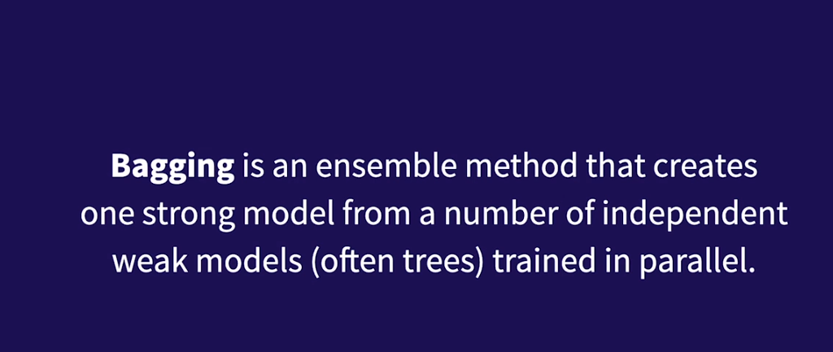

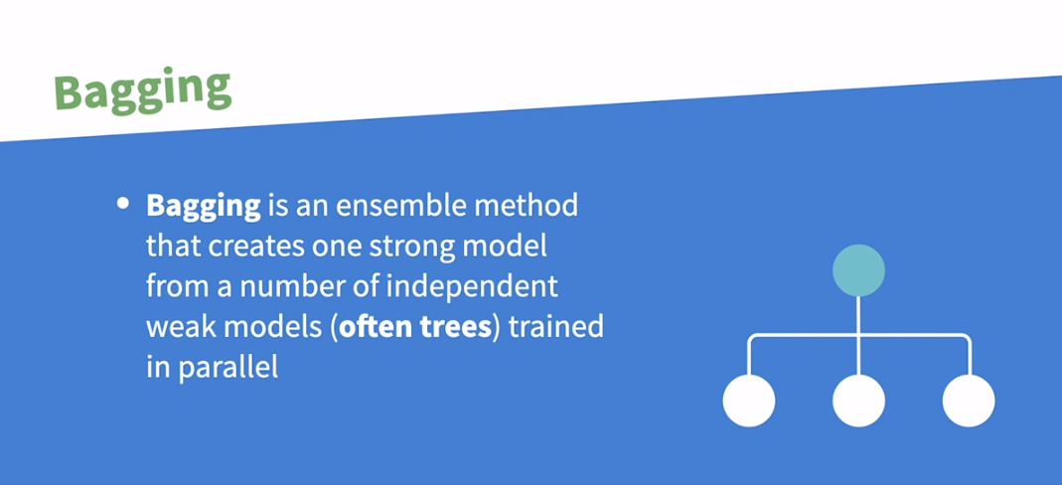

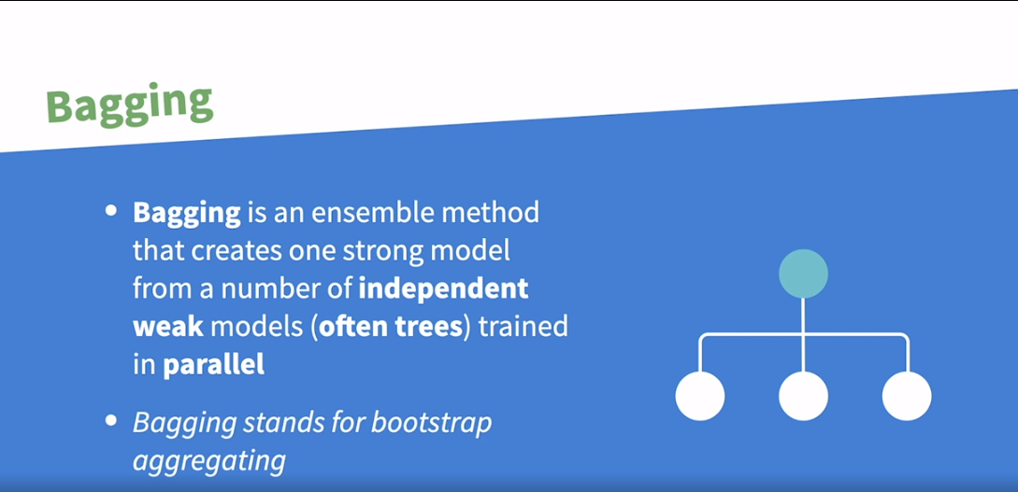

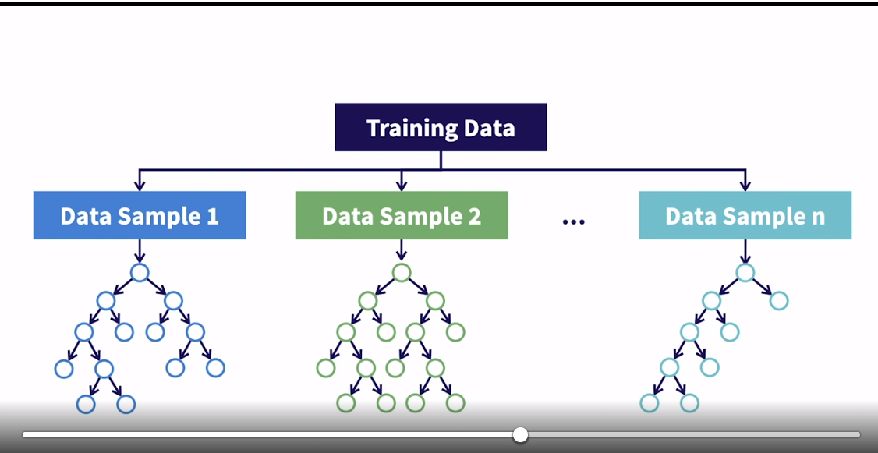

No correlation i.e. build on subset of data

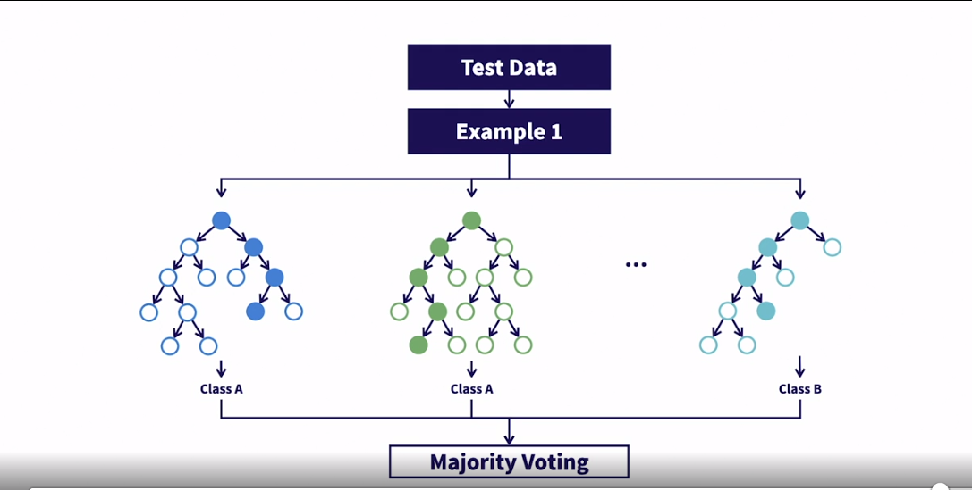

### **How does bagging reduce overall error?**

Selecting transcript lines in this section will navigate to timestamp in the video

- [Instructor] Let's dig into how bagging reduces overall error. Let's start by revisiting this plot we looked at previously. So total model error is roughly made up of model bias plus model variance. Overly simple and overly complex models both result in high error models. Overly simple error is driven by high bias, while overly complex error is driven by high variance. We're aiming to find the right trade off between bias and variance to achieve the lowest total error possible. In the last chapter, we talked about how boosting starts with extremely simple models that are underfit, then the process of boosting, where we're training on the errors of prior models, allows us to drive down that bias to achieve the optimal trade off and reduce overall error. Bagging takes the opposite approach. It starts with more complex models that tend to be low bias, high variance, and then the process of bagging will drive down the variance to achieve the optimal trade off. Let's revisit the diagram from last video in order to better understand how bagging achieves that. We've taken n samples and generated n deep decision trees representing our weak models. Each of these trees will represent a weak model where the total error is driven by the high variance. The upside of these models is that they do have low bias. So let's circle back around for a second to our dartboard analogy to recall what high variance and low bias actually means. Variance is an algorithm's sensitivity to small fluctuations in the training data, and high variance comes from an algorithm fitting to the random noise in the training data. In other words, it's due to the model overfitting to the training data, rather than just fitting to the proper trends in that data. On a dartboard, low bias means it will be centered around the bullseye, but the high variance means it'll rarely actually hit the bullseye. So what bagging does is it reduces the variance while maintaining that low bias. So let's jump back to our diagram. How does bagging take all of these high variance weak models and combine them into a low variance weak model? By simply giving each of them a voice. Thinking about it practically, and again, remembering our dartboard analogy, each point represents a low bias, high variance outcome. Each point represents one of our weak models, basically. Now, if you allow all these points to effectively work together to find the bullseye, it can be really powerful. To put it another way, if you effectively average all of these points or you find the center point, you'll end up with a point in or near the bullseye. In technical terms, that means you reduce the variance of the overall framework to find a low bias, low variance solution in or near the bullseye. Bagging effectively works the same way. With enough votes, the variance of all the individual models effectively cancel each other out, resulting in a low bias, low variance model. Another great perk is that bagging protects against overfitting to your data. Individual decision trees are prone to overfitting, that's why they're high variance, but by giving each tree a voice to vote on the final outcome, you nearly eliminate the risk of overfitting. Compare this to boosting, where you're consistently learning from the mistakes of prior models on the training data. You do run the risk of doing that too many times and then just overfitting to the training data and correcting every mistake that you made on the training data. So bagging is an incredibly powerful tool that allows you to efficiently find a low bias, low variance model. In the next lesson, we'll talk about when you should use it and when you should not use it.

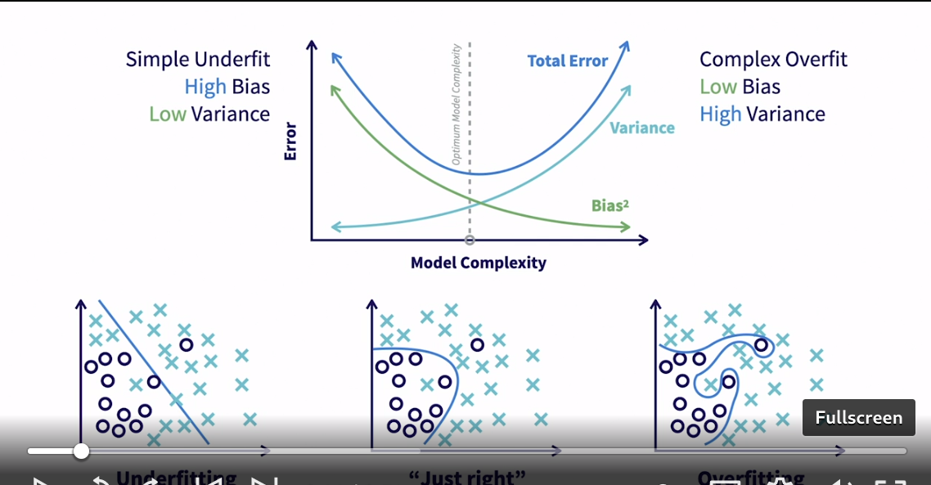

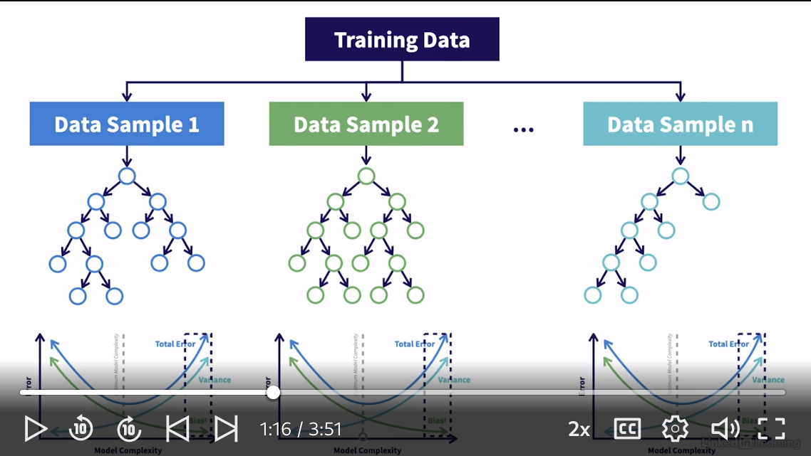

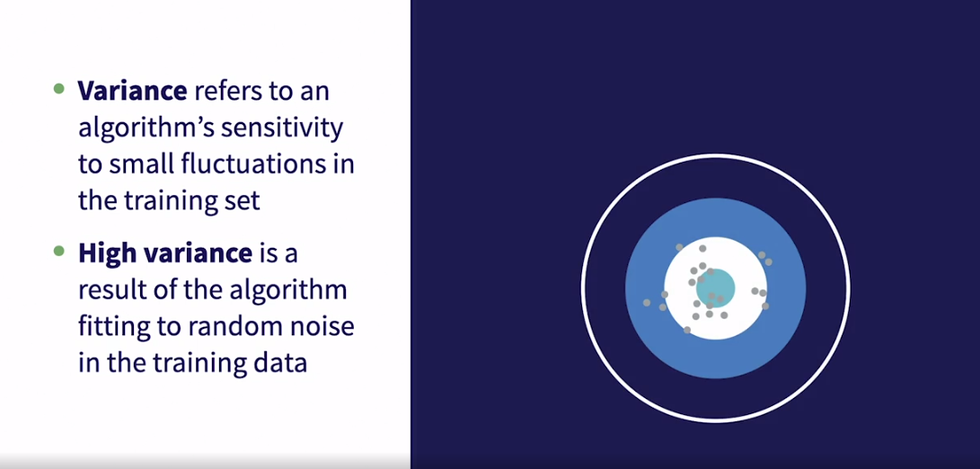

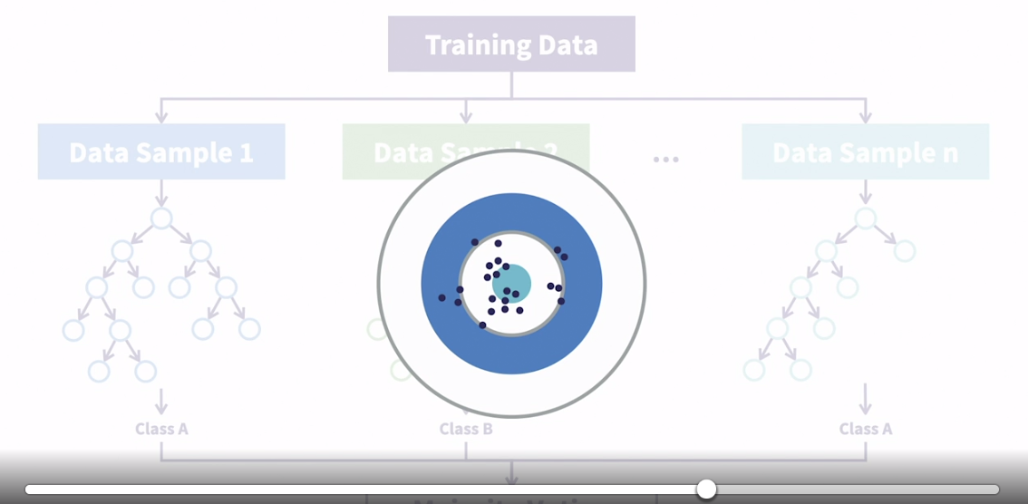

### **When should you consider using bagging?**

Selecting transcript lines in this section will navigate to timestamp in the video

- [Instructor] In this lesson, we're going to talk about when you should and should not use bagging. Just like we saw with boosting, bagging works quite well for problems with both categorical and continuous target variables. Again, similar to boosting, one of my favorite things about bagging is it has an attribute to layout the importance of each feature you're using. This is really nice to understand the relationships between the features and the thing you're trying to predict. Bagging is extremely flexible, relatively quick to train, and it tends to perform quite well on most problems, which makes it a great candidate to be your first quick benchmark model. And oftentimes this may very well actually be your best model. On the note of flexibility, when you have really messy data with missing values, outliers, skewed data, and so on, bagging is often a great choice because it deals really well with that messy data. So when should we not use this? While bagging is fairly fast, quite flexible, and it performs well, it's not necessarily likely to be the best model for any given problem. If you want a quick model that gets you 90% of the way there this probably is the right tool for your job. If you really need to get 100% of the way there and extract all possible signal of the data bagging might not be the right tool. There are other more powerful algorithms out there. While it's nice to understand the features and the decision trees on their own can be fairly easy to understand, having a collection of hundreds of decision trees it can be quite hard to interpret what's happening across the entire model. So if you need to see the details within the model, bagging might not be the right choice. Remember last chapter where we referred to boosting as a black box algorithm, the same applies to bagging. While bagging models are relatively quick to train because they are parallelizable, they are not quite as quick to make predictions as boosting models because the trees are so much deeper than they are for boosting. Overall bagging is a tremendously flexible, relatively fast tool that works pretty well for almost any problem. That's a really nice swiss army knife to have in your tool set.

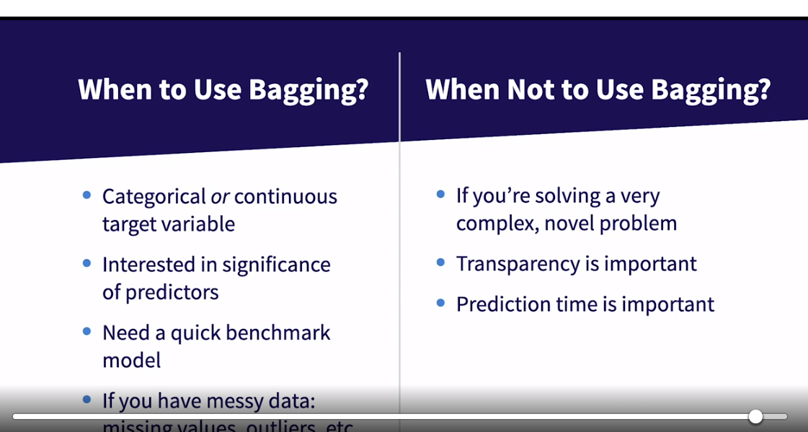



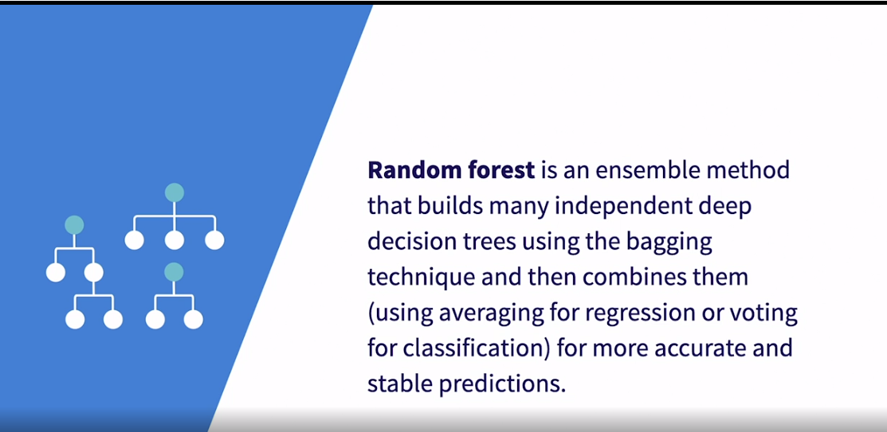

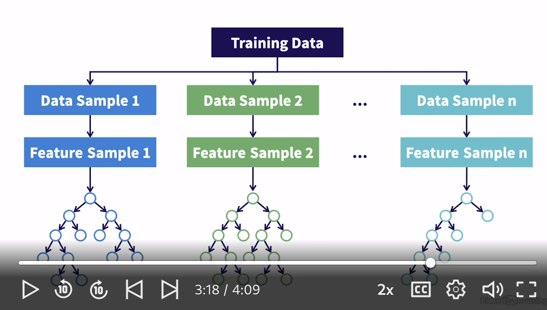

### **Explore bagging algorithms in Python**

Selecting transcript lines in this section will navigate to timestamp in the video

- [Instructor] In the last video, we talked about how Random Forest is the most popular algorithm that leverages bagging. So in this video, we'll explore some of the key hyper parameters for Random Forest. Again, we're only looking at the classifier here since our Titanic data set is a classification problem, but there's also a random forest regress tool in scikit-learn. So we'll start by importing Random Forest classifier from scikit-learn.ensemble, and then we're going to call the parameters in the same way we did with the boosting models. So copy down Random Forest classifier, we'll leave some open parentheses, then we'll call the get_params method. So here are all the potential hyper parameters we could tune, and this might look a lot like gradient boosting. It's true. A lot of the hyper parameters are the same because they're both tree-based methods with that said, we're only going to be focusing on two hyper parameters here. Those two are n estimators, or number of estimators, and max depth. These two are define the same way we did for gradient boosting, and estimators is the number of base models or number of individual decision trees, and max depth is the depth of each individual decision tree. One difference I want to call out is that max depth for gradient boosting was set to three, while max depth for Random Forest is set to none. That means the decision tree can grow as deep as it needs to in order to find the optimal model. So by default, Random Forest will build 100 independent really deep trees in parallel. Gradient boosting by default will build 100 trees with a max depth of three. These trees will be built so sequentially where each tree is trained on the mistakes of the prior trees. Remember, this all comes back to the bias variance trade off, where boosting starts with high bias low variance base models, and reduces the bias through boosting, whereas bagging starts with low bias, high variance models and reduces the variance through bagging. In the next lesson, we'll actually fit a Random Forest model.

### **Implement a bagging model**

Selecting transcript lines in this section will navigate to timestamp in the video

- [Instructor] In this final video in the Bagging Chapter, we're going to try to build the best Random Forest model we can on this Titanic dataset by using the same process we did for gradient boosting. So we'll search for the best hyper parameter settings for the Random Forest model using grid search CV. So let's start by importing the same packages we imported in the last chapter, so that's joblib in order to save out our model, pandas to read in our data, and then our classifier and grid search CV from sklearn. Then we'll just read in our training features and the training labels. Recall this helper function we used in the last chapter to help us print out the average accuracy score and the standard deviation of the accuracy score across five folds built into our cross validation for each hyper perimeter combination. So let's walk through this code again for grid search CB. This should look familiar as it's basically the same as what we ran for gradient boosting. We have this Random Forest classifier object and we store it as RF. Then we have to define our hyper parameter dictionary. So the keys in the dictionary align with the name of the hyper parameters that would be passed into Random Forest classifier. So that's n_estimators and max_depth. And then we just need to define the list of settings that we want to test for each hyper parameter. So for the number of estimators we'll build out 5, 50, 250 and 500 trees. And then for max_depth we'll test out 4, 8, 16 32, and just a reminder, none will indicate that the tree should be built as deep as it needs to be until it achieves some level of training air tolerance defined within Random Forest classifier. So you'll notice we're testing deeper trees here than we did for gradient boosting. And that's expected based on the way that we know these two algorithms optimize that bias variance trade off. Random Forest starts with deep trees that have high variance and low bias. So now let's create our grid search CV object. So we'll call GridSearchCV. We're going to pass in our model object then pass in our hyper parameter dictionary. Lastly, we have to define the number of folds in our cross validation. We'll keep it at five, just like we did in the last chapter. We'll sign all of that to CV. Then, just as we do for all sklearn objects, we call the .fit method and we pass in the training features and the training labels. And one more reminder that these training labels are stored as a column vector and we need to convert it to an array for sklearn. So we just call it .values.revel and again, GridSearchCV will run five fold cross validation for each hyper perimeter setting combination to determine the best model. And then we just want to print out our results using this print results function. So we'll copy that down here and we'll just pass in our GridSearchCV object. So go ahead and run that. Before we dig into these results, I want to call out that even if I ran this same exact cell again with the same exact training set, I would get different results. That's because each time you run Random Forest it's randomly sampling the rows and the columns internally like we discussed earlier in this chapter, to build each decision tree. So you could get different results each time you run Random Forest. Also remember that these results are on unseen data thanks to the way cross validation built into GridSearchCV, splits up the data. Now looking at the results, the best results are using 250 estimators with a max step of eight, which gives us an overall accuracy score of 82%. Feel free to dig through these results to better understand how each of our two hyper parameters are impacting the results. Then let's ask GridSearchCV object to print out the best model based on performance on unseen data. Just like we did in the last chapter, we'll call cv.best_estimator. And it'll tell us it's the model with a max depth of eight and 250 estimators. Lastly, we'll just write out the fit model using joblib.dump. So we'll call joblib.dump. Then we have to tell it what we want to save out. We want to save out our best_estimator. Then we have to tell it where to save it. So we have to go up a couple of directories and then save it to models and we'll call it RF_model.pkl. In the next chapter, we'll cover the last of our ensemble techniques, stacking.

## **Question 1 of 4**

When this command is executed, what will be shown as the default value for the maximum tree depth?

RandomForestClassifier().get_params()

* 'max_depth': None
* Correct
* 'max_depth': True
* 'max_depth': 3.0

## **Question 2 of 4**

How does bagging work?

* It reduces variance while maintaining low bias.  
  Correct
* It reduces variance while maintaining high bias.  
  Incorrect
* It increases variance while maintaining high bias.  
  Incorrect
* It increases variance while maintaining low bias.

## **Question 3 of 4**

Bagging is a good choice when you have what type of data?

* messy data with missing values and outliers  
  Correct
* clean data with no missing values or outliers
* data with no variance

## **Question 4 of 4**

What command prints the best model from a GridSearchCV operation?

* best_estimator_
* Correct
* best_fit_
* Best_model

### **What is boosting?**

Selecting transcript lines in this section will navigate to timestamp in the video

- [Narrator] Let's dig into our first of three ensemble techniques that we'll be covering in this course. Boosting is an ensemble method that sequentially trains a number of weak models, often trees, to create one strong model. This sounds a lot like our general definition for ensemble learning, but there're two things that I want to emphasize here. The first is that boosting often leverages decision trees as their base models. And the second is that boosting really enforces that these base models are weak. Again, by weak model, I mean one that is only a little better than guessing. And boosting forces these base models to be weak by capping the maximum depth of the trees that make up those weak models. This is an effective way of capping the power of those base models. There's one critically important factor that makes boosting so powerful, and it separates it from most other ensemble learning techniques. That is that these weak models are trained sequentially, and what boosting does is it evaluates each weak model to identify what it's getting wrong. And then, the next weak model focuses on that aspect of the data. So while each individual model is weak, together they're incredibly powerful, because they're intentionally trained to pick up on what the other models are missing. This is unique to boosting, makes it really powerful. Now, let's take a look at a diagram to see how boosting works. So you'll start with your training data and you take a sample of data from it. With that sample, you'll build a simple decision tree. And I do want to call out that this tree is very shallow. Again, this is because we want these individual base models to be weak learners, and a shallow tree is more likely to be a weak model. Then, the algorithm will evaluate the performance of that first model, and it will resample while overweighting the examples that were misclassified by the prior model. Essentially, it assumes that this model has a good handle on any examples that are correctly classified, so the next model should focus on the ones that the first model couldn't quite figure out. So once this next sample is set with a higher proportion of examples that were misclassified by the prior model, it builds a new weak model that hopefully keys in on what the prior model missed. Then, it repeats this evaluation, sampling process over and over. So each model will attempt to learn from the mistakes of the prior models. So by the end, you have n relatively weak models, but as a whole, they've learned from the mistakes of all prior iterations, so they represent a very strong model. With that in mind, let's look at how boosting aggregates all of these individual models to generate one prediction. One thing I want to call out here is you cannot train these base models in parallel, because each model builds on the prior model. This is one of the main drawbacks of boosting, is it's expensive to train due to the sequential nature. But in prediction, you can parallelize it, because all the individual trees or models are already built. So that's why you'll learn that boosting is very slow to train, but it's fast to make predictions. So we start with our end weak models that we built in training, and then, we'll feed in the first example from the test data and each weak model ends up generating a prediction. Now, remember in the last chapter, we talked about there being some metamodel to create a final prediction, and with bagging and boosting that metamodel is often something as simple as averaging or voting. For boosting, it's a weighted voting based on how well each individual base model performed in training. Remember, after each weak model was built in training, we evaluated it to figure out which examples it got wrong. That performance is then used for waiting these final votes, so the best individual models get more say in the final prediction. Ultimately, the weighted vote ends up generating the final prediction. This model's ability to learn from its own mistakes and then calibrate the weighted voting based on the performance of each weak model, makes this a tremendously powerful algorithm, that is one of the most used algorithms in machine learning.

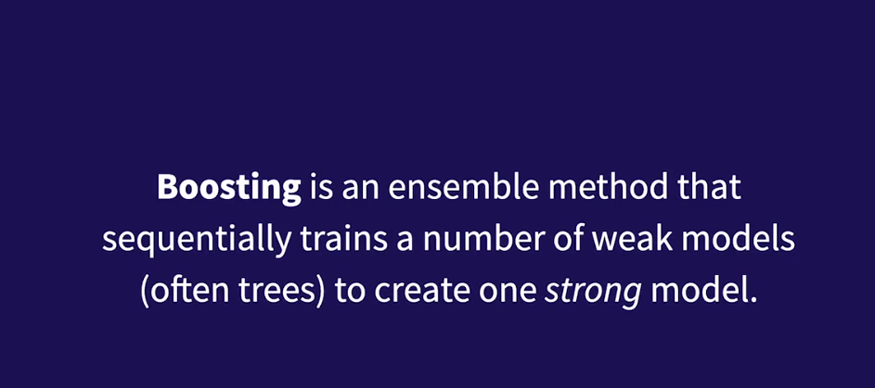

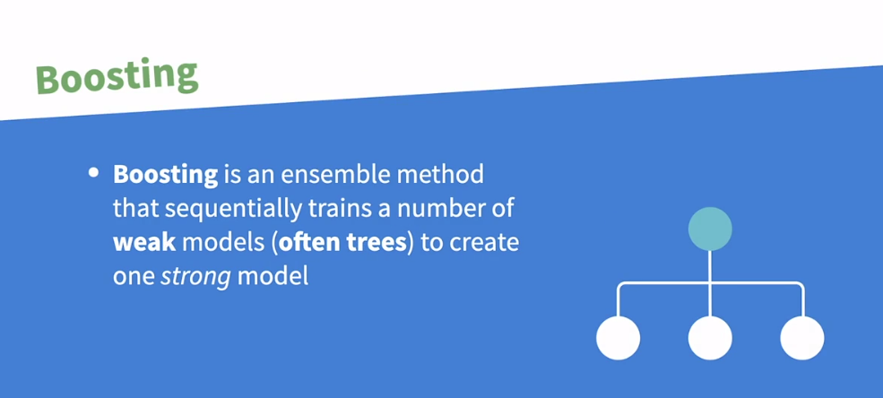

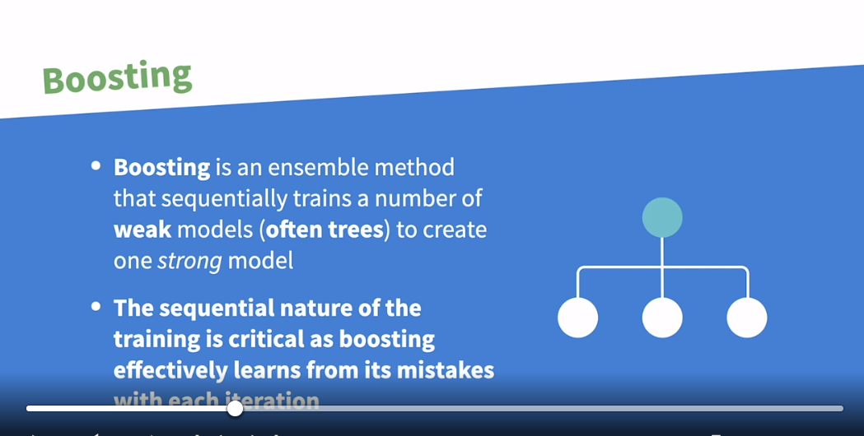

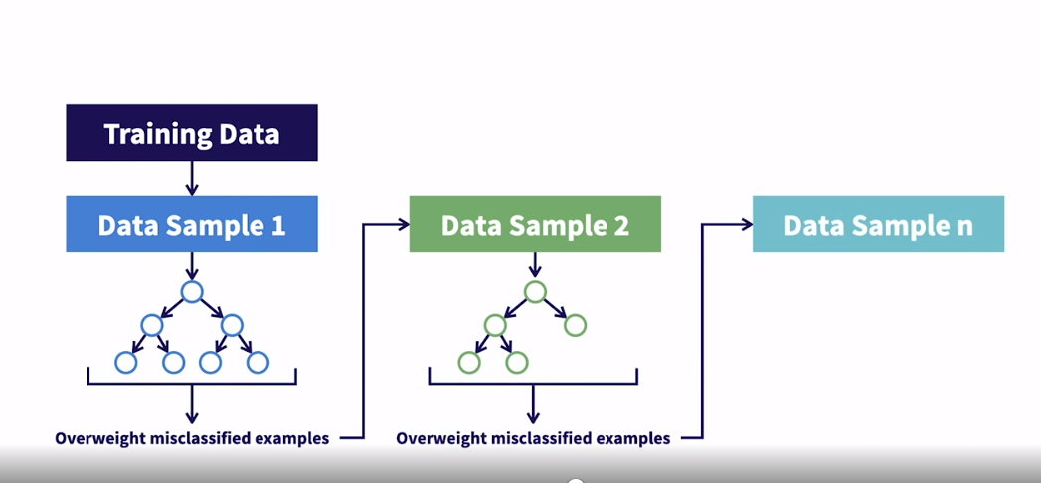

### **How does boosting reduce overall error?**

Selecting transcript lines in this section will navigate to timestamp in the video

- [Instructor] Let's dig into how boosting reduces overall error. In order to do that, let's quickly revisit this plot we looked at when we talked about the bias variance trade off. So just a reminder, total model error is roughly made up of model bias plus model variance. So as model complexity goes up, bias goes down but variance goes up and vice versa. So there's this trade off between bias and variance and we're aiming to find the right trade off to generate the optimal model with the lowest total error. Very simple models on the left side of this plot will be under fit to the data and they'll have high bias and low variance, which will result in high total error. On the bottom of this slide, you could see that this results in a decision boundary that is extremely simple and may do a decent job splitting your classes but it certainly could be better and that's why we refer to it as under fit. We call the errors that's making here bias errors because the decision boundary is not complex enough to properly fit the trends in the data. On the right side of this plot we have very complex models that are over fit to the training data, and they have very low bias but high variance resulting in high total error. The reason they have high variance is because they're so closely fit to the training data. Sometimes they're simply memorizing the training data. So any slight fluctuations in that training data will negatively impact the model predictions because it didn't fit to the trends in the data. It just memorized the training data. And that results in a decision boundary on the bottom right of this slide here, that's very complex and it's trying to classify every single training example correctly. Then in the middle we have a properly fit model with relatively low bias and low variance, resulting in low total error. You could see it at the bottom of this slide that this model will pick up on the signal in the data but it will not over fit to the training data and try to properly classify every single point in the training data. This type of model is what we're aiming for. So just putting this all together, here's the full range of outcomes. So let's apply this to boosting. Remember we started with a data sample from the training data. Then we built a very simple model on that sample of training data. Again, often it's tree based. We know this model is simple because the tree is so shallow and because the model is so simple, it typically means it's under fitting the data. Remember that means we'll be on the left side of this plot where this first model has low variance but high bias. Because it's not complex enough to identify the trends in the data, it results in this extremely simple decision boundary that is too simple to properly classify a lot of the data in the training sample. Now recall what boosting does that's so powerful is it evaluates the model to identify what it's getting wrong. Then for the next data sample, it over samples the examples that the prior model got wrong. Remember we call these errors bias errors because they're errors due to the model being too simple to properly fit to the trends in the data. What that means is that this next model will focus on the areas that the prior model struggled with, these bias errors. So now when the second week model is built, it reduces the bias of the overall model by just a little bit because it's focusing on the bias errors from the prior model and building on that to make the overall model just a little bit more complex so that it makes fewer bias errors. Then we'll repeat this process n times where we are sequentially building models that are learning from the mistakes of the prior models by oversampling the misclassified examples. This results in a highly optimized model where we're taking N very simple high bias, low variance models and we maintain that low variance by keeping the base models very simple but through the process of boosting, we drive down the bias by allowing each sequential weak model to learn from the mistakes or the bias errors of the models before it. Now in the next video, we'll talk about when you should and should not be using boosting.

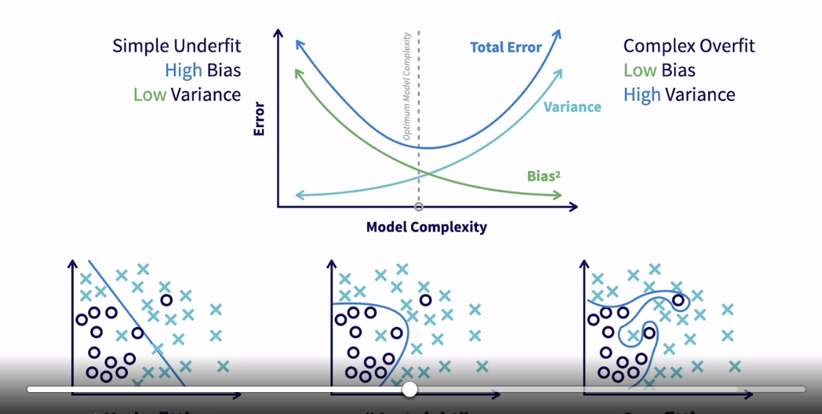

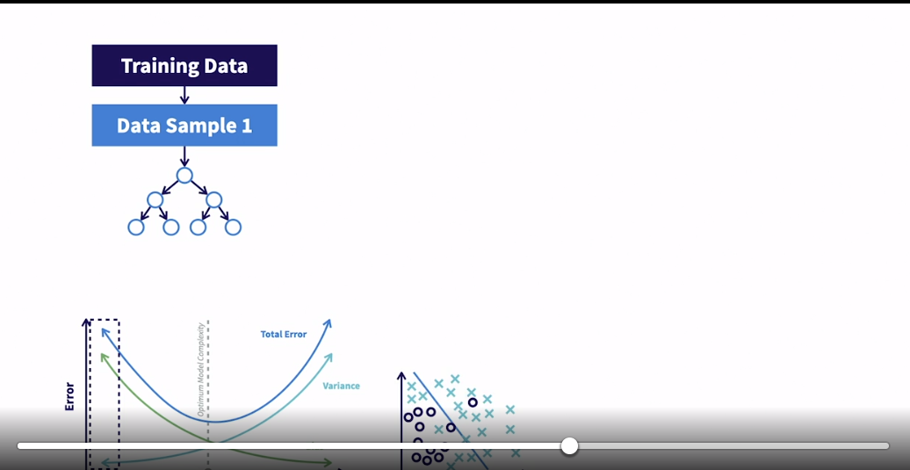

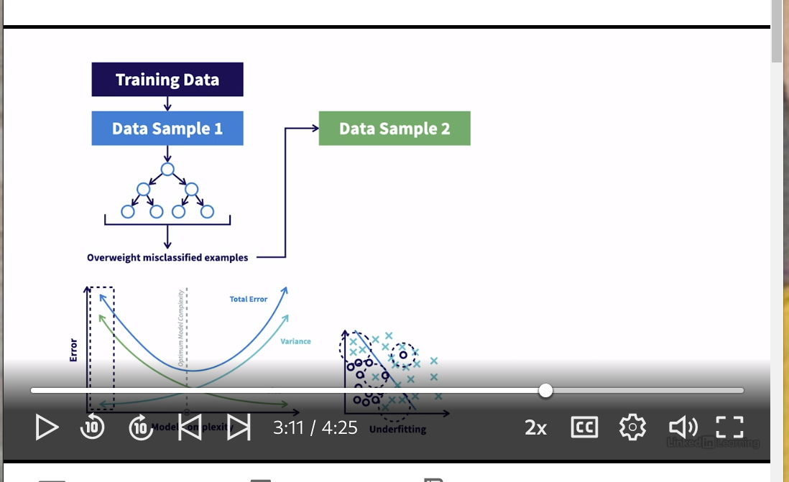

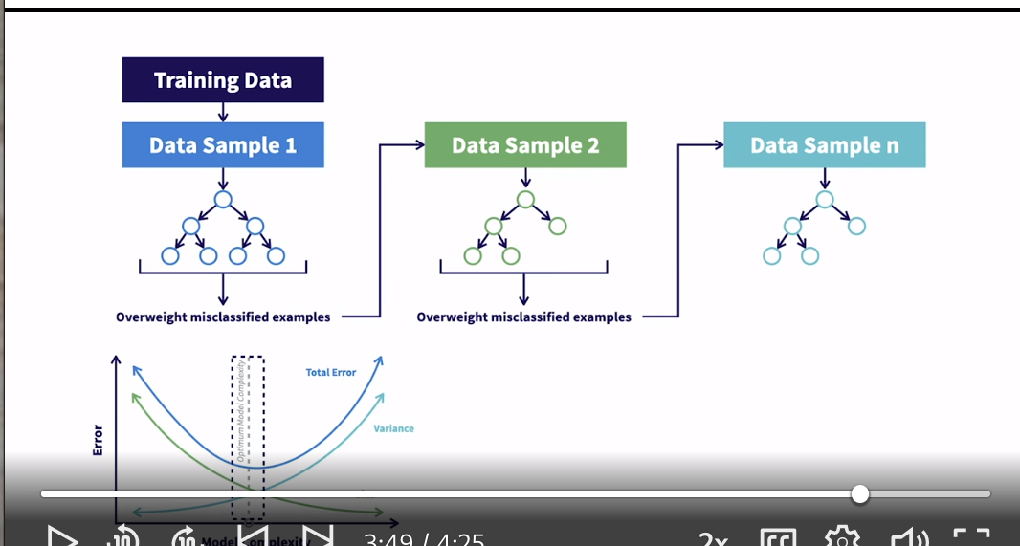



### **When should you consider using boosting?**

Selecting transcript lines in this section will navigate to timestamp in the video

- [Instructor] We've talked quite a bit in this chapter about the different attributes of boosting and how powerful it is. With that said, you shouldn't approach any machine learning problem with just a single hammer. You should understand which algorithms apply to which types of problems. So in this video, we're going to talk about when you should and should not use boosting. Boosting can be used for classification and regression problems, meaning it can be used to predict categorical outcomes and continuous outcomes. It's important to note that this is not true of all algorithms. This makes boosting quite flexible in terms of the types of problems it can be applied to. One of my favorite things about boosting is it's pretty much ready to go right out of the box. It can handle different data types for features. It handles missing values and so on. There's very little data handling that's really required before passing your raw data into a boosting algorithm. One of the other great things about boosting is that it has an attribute that lays out the importance of each feature you're using. Here's an example of what this looks like using the Titanic data set. The values on the x-axis aren't terribly important. It just helps you understand the relative importance of each feature. And this is really nice to understand the relationships and the power of each feature in your model. Now, we talked about this earlier in the chapter as well. But remember, while the training was sequential, the prediction for boosting was in parallel. And since each individual base model is really simple, this makes boosting quite fast at prediction time. So if prediction time is really important, boosting should be one of the first tools that you look at. For all the power and benefits that boosting brings to the table, it's not without its flaws. So when should we not use it? Boosting models contain so many base models under the hood that it can be really difficult to understand while each individual weak model is quite simple, when you have tens or hundreds of them, it can be difficult to wrap your head around. For that reason, boosting models are not very transparent. It's not easy to understand why it's making a certain prediction. So if transparency is critically important to the problem you're trying to solve, you might want to avoid boosting. In machine learning, we call this a black box model. You pass data in, it runs a bunch of operations inside the black box, then it outputs an answer, but it's not always totally clear what happened inside that black box to come up with this answer. The sequential nature in training the weak models where each successive model learns from the mistakes of the previous models makes this a really powerful algorithm, but that sequential nature also makes it really slow to train. So if you have limited time or compute power, boosting might not be the first option for you. One of the main issues with boosting is it has a tendency to overfit because it constantly learns from its own mistakes. By design, a model should not fit to noisy data or outliers. But if a model's always trying to fix its own mistakes, it might learn to fit to those outliers. So if your data is really noisy, I won't say that you can't use boosting but you need to be careful and be aware of its tendency to try to fit to that noise. In summary, boosting is one of the most flexible, powerful tools out there. And honestly, you should consider it for almost every problem. With that said, you do need to consider that it'll take a long time to fit and you have to be careful of its tendency to overfit.

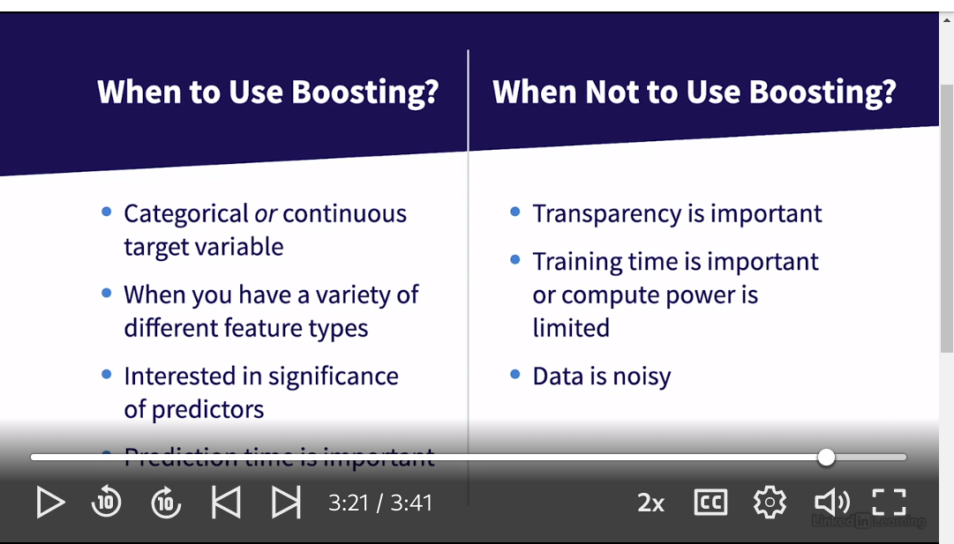

### **What are examples of algorithms that use boosting?**

Selecting transcript lines in this section will navigate to timestamp in the video

- [Narrator] In the last two videos in this chapter, we're going to actually write the code to implement a boosting model. To prepare for that, let's discuss two commonly used machine learning algorithms that leverage boosting, adaptive boosting and gradient boosting. These two algorithms are very similar, but in this video we're going to focus on a few of the differences that make them distinct algorithms. It's worth noting that the diagrams we've been looking at earlier in this chapter are based on adaptive boosting, but would only require a couple very small tweaks to apply them to gradient boosting. It's also worth noting we'll be going into pretty deep technical detail in this lesson, but it's not really necessary to fully understand all of these differences to be able to implement these algorithms. We could spend an entire course on these technical details. So if you find a particular detail or difference interesting, feel free to continue your own research. The first difference between these two algorithms is how they directly reduce bias. As we talked about earlier in this chapter, adaptive boosting reduces bias by oversampling misclassified examples from prior weak models. Gradient boosting does this by training on the actual errors or residuals rather than oversampling the misclassified examples. The second difference is that adaptive boosting can technically accept a variety of algorithms as its base models. Though it's worth noting that it still does usually use trees as we saw earlier in this chapter. You'll see when we move to the implementation stage that adaptive boosting accepts a base estimator parameter that allows you to dictate which algorithm you want to use for the weak learners. In contrast, gradient boosting always uses decision trees. Earlier in this chapter, we talked about how our meta model or our strong model, makes the final prediction using weighted voting where each weak model is weighted based on how well it performed in evaluation. That's how adaptive boosting optimizes the strong learner. Gradient boosting optimizes a little bit differently by using gradient descent optimization, which is where it gets its name from. The last difference we'll discuss is the loss function. Every machine learning algorithm has some loss function that it seeks to optimize to achieve the best model. Some loss functions are better than others for certain types of problems. Adaptive boosting uses an exponential loss function, whereas gradient boosting is a little bit more flexible and accepts exponential or deviance. One final note, you may have heard of XGBoost, is that's another popular algorithm. XGBoost stands for extreme gradient boosting and it's a speed optimized implementation of gradient boosting. So you can assume most of the details are the same as gradient boosting. Hopefully, so far this chapter has given you a good idea of what boosting is, how it reduces errors, when you should use it, and the different types of algorithms that use boosting. In the next video, we're going to explore these boosting algorithms in Python.

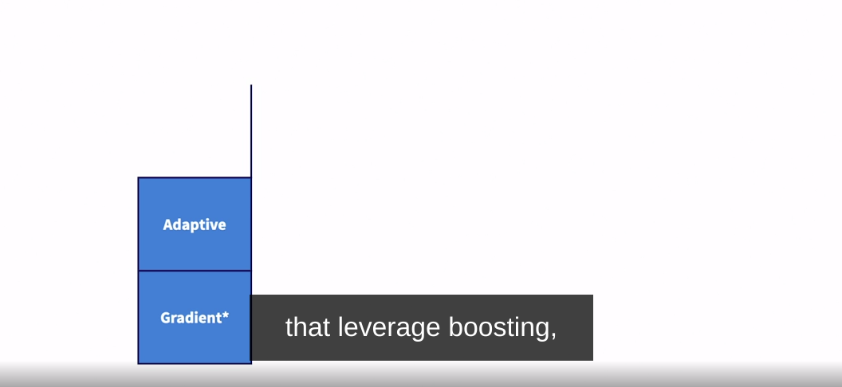

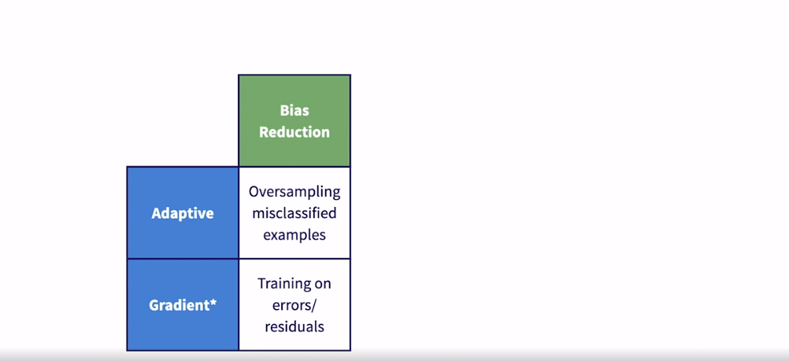

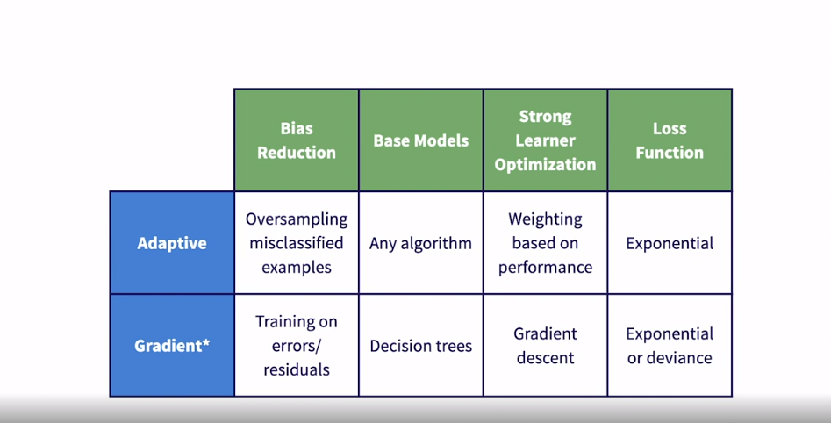



### **Explore boosting algorithms in Python**

Selecting transcript lines in this section will navigate to timestamp in the video

- [Instructor] In this video, we're going to import the gradient boosting and AdaptiveBoostingClassifiers used in Python and explore some of the key hyperparameters to tune. We're only looking at classifiers here since our Titanic dataset that we'll be working with is a classification problem, but there are also equivalent tools in Python for regression. So let's start by importing both the GradientBoostingClassifier and AdaptiveBoostingClassifier. So do that by calling them from sklearn.ensemble. We'll say import GradientBoostingClassifier and Adaptive Boosting, which is classified as AdaBoostClassifier. And then, we're going to start by exploring the hyperparameters for gradient boosting, and then, we'll look at adaptive boosting in just a minute. So we can view all available hyperparameters by calling the get_params method. So I'm just going to copy down this GradientBoostingClassifier, leave open parenthesis, and then call the get_params, open parenthesis method. Now there are a lot of hyperparameters that we could explore here and I encourage you to take a look at those in the documentation linked up above in this notebook. In the interest of time, I'm just going to focus on some of the most important hyperparameters. Now remember, gradient boosting is made up of a lot of really shallow decision trees. So this end estimators parameter controls the number of trees that the algorithm should create. The default is set to 100. And then the max depth is the maximum depth of those trees. And the default is set to three, which is quite shallow. So by default, gradient boosting would build 100 trees of depth three that would represent its base models. Lastly, there's a learning rate parameter that effectively controls how quickly the algorithm attempts to optimize. If learning rate is really low, it may take longer for the algorithm to fit and it may not end up finding the optimal model. It may get stuck in what's called a local minimum, meaning it finds a pretty good answer, but not the best answer, which would be called the global minimum. On the other side, if you set learning rate really high, the model may fit quicker, but again, you run into the risk of finding a suboptimal model. So in other words, learning rate allows you to control the balance between the time to fit and how well the model fits. So now let's take a look at the hyperparameters for the AdaptiveBoostingClassifier by calling that same get_params method. So let's copy down our classifier that we imported, leave open parentheses, and then we'll call the get_params method. So you'll see right off the bat that there's a much smaller set of hyperparameters here. So let's start with the algorithm. This is the actual boosting algorithm used and the default is the true boosting algorithm that we already talked about and you'll want to leave it as that. The base estimator refers to the type of weak models that you'll use. Remember, one of the differences between gradient boosting and adaptive boosting is that gradient boosting requires the use of the decision trees for the base models, but you don't need to use decision trees in adaptive boosting. You can use, for the most part, whatever algorithm you want. Then learning rate is the same as it is for gradient boosting. It controls the trade-off between the time to fit and how well the model fits. And end estimators is the number of base or weak models that you want. By default, it's set to build 50 of whatever model you declare in base estimator. In the next and final video in this chapter, we're going to actually fit a gradient boosting model.

### **Compare the three methods**

Selecting transcript lines in this section will navigate to timestamp in the video

- [Instructor] In this video, we're going to take a step back and compare the three ensemble learning techniques that we've learned about in prior chapters. We'll review what we've learned about each, directly compare them all, and then we'll set the appropriate context to compare our best models on the validation and test data in the next video. We'll start with Boosting. Remember that the weak models or base models in Boosting, are learned sequentially because each successive model is trained on the heirs of the models before it. These weak models are typically very shallow, under fit, high bias, low variance trees. Then these are all combined using weighted voting for classification or averaging for regression. Gradient Boosting and adaptive Boosting are two examples of algorithms that leverage Boosting. Next up is Bagging. Unlike Boosting, Bagging trains independent week models in parallel where each week model is a deep, often overfit low bias high variance tree. Then all the weak models are combined using standard voting or averaging. Random forest is the most popular algorithm that leverages Bagging. The only tweak on standard Bagging that random forest implements, is that for each week model it's not only built on a sample of the data but also on a sample of the features. This ensures that each week model is independent, uncorrelated, and focusing on a certain aspect of the data. Last up is Stacking. Like Bagging, Stacking trains independent base models in parallel where each week model is often low bias high variants. In Stacking, each base model is trained on the full data set, unlike in Bagging and those base models do not have to be trees. Also, unlike in Boosting and Bagging where the Metamodel is simply evoting or averaging, Stacking involves a real trained Metamodel on top of the predictions from the base models. One final reminder that Boosting start with high bias, low variance models, and reduces the bias by each model training on the heirs of the models before it. Remember our dartboard analogy. High bias, low variance means a very tight range of outcomes but not centered on the bullseye. The process of Boosting allows each successive model to learn in what way prior models were missing the bullseye. Allowing it to move closer and closer to the bullseye, which in machine learning, means it is effectively reducing bias. Bagging and Stacking both start with low bias, high variance models, and reduce the variance by allowing each base model to contribute to the final answer where effectively their variants tends to cancel each other out. Recall our dartboard analogy where all these independent models are roughly centered around the bullseye but it's a wider range of outcomes. When each gets a voice and they work together, that variance effectively cancels each other out to find the bullseye. Okay, now we're going to attempt to compare these three methods directly across a few dimensions. It's worth noting here that we're speaking in extremely general terms. Just because we mark Boosting as being able to make faster predictions than Bagging, it doesn't mean that will be true in every single scenario. It'll depend on the problem and how you configure your model. First up, in Boosting, the training data is sampled where misclassified examples from prior models are overweighted so that each success in model learns from the mistakes of prior models. Bagging just takes a random sample for each base model just to try to make sure each model is independent and uncorrelated. Lastly, there's no sampling for Stacking. Each base model is trained on the full training set. Next up, is describing the type of base models, each ensemble technique relies on. Boosting starts with high bias, low variance base models, while both Bagging and Stacking start with low bias, high variance base models. Training speed can be pretty directly tied to whether training can be parallelized and the complexity of the base models. So Boosting has simple base models but you can't parallelize the training which really slows it down. Bagging starts with complex base models but it can be trained in parallel, so it's moderately fast. Stacking is the same as Bagging. Starts with complex base models but it can be trained in parallel so it's also moderately fast. Again, I'm going to say that this is likely the one that fluctuates most depending on how you're structuring your model, the data, and even the architecture the computer that you're training it on. Some computers are better set up to run the parallelization that you can do with Bagging and Stacking. So these labels are broadly true but it should be noted that it can vary from one problem to the next. For prediction speed, Boostings very fast because the base models are so simple and while training cannot be parallelized, prediction can be parallelized. Bagging and Stacking are not the slowest models out there for prediction time, but they're also not the fastest. Prediction can be parallelized but the base models are more complex than the base models for Boosting so they tend to be a bit slower. Lastly, none of these techniques generate models that are terribly transparent. If interpretability is important to you, you may want to consider a different algorithm. Now, before we jump into evaluating our three models on the validation and test data, let's revisit where we are in the standard machine learning pipeline. This diagram will look familiar from our earlier review chapter. So we started back in the second chapter by exploring and cleaning our data. Then we split the data into training validation and test sets and we wrote these out to ensure that we're using the same exact data for each ensemble technique. Then over the last three chapters, we fit models using fivefold cross validation. And then we use grid search to find the best hyper perimeter settings. Then we saved out the best model from each of our three techniques. Now this is the stage we're at now. We have our three best models based on the training set, now we want to evaluate those three models against each other on data they have never seen before in the validation set. Then we'll select the best model based on performance on the validation data and then we'll evaluate it on the test data to give us one final, completely unbiased view of how our model will do on unseen data. This evaluation on the test data is particularly important if you're planning on putting your model into production where it'll run in some automated fashion on data that's never seen before. This is the best estimation of how it will perform. With all that covered, let's jump into evaluating our final models on the validation and test set in the next video.

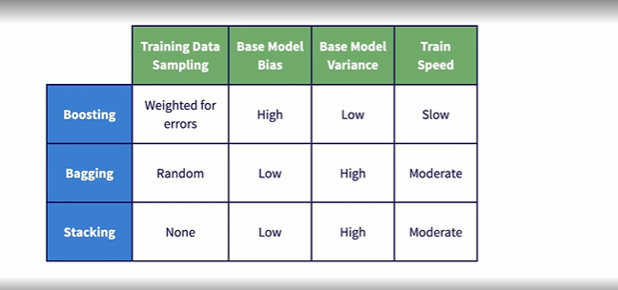

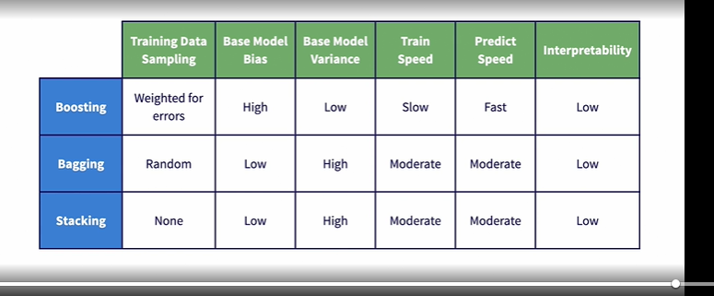

## **Question 1 of 2**

Which attribute is the same for all three ensemble learning algorithms?

* predict speed, which is fast
* training speed, which is slow
* interpretability, which is low  
  Correct

## **Question 2 of 2**

What is the correct command to import the three standard metrics used to evaluate performance on a classification problem?

* from sklearn.metrics import training_score, variance_score, bias_score
* from sklearn.metrics import accuracy_score, precision_score, recall_score
* Correct
* from sklearn.metrics import performance_score, prediction_score, recall_score

### **Compare all models on validation set**

Selecting transcript lines in this section will navigate to timestamp in the video

- [Instructor] So now we've learned about three different ensemble learning techniques, how they minimize error, and why they're so powerful. Then we actually built some models and used Grid Search CV to do hyperparameter tuning to find the best model for each ensemble learning technique. In this video, we're going to pick up those three models that were fit on the training set and we'll evaluate them against one another on the validation set. This will give us a view of how the best models generated by each ensemble learning technique will perform on data that they were not fit on. Then we'll select the best model based on the performance on the validation set and evaluate it on the holdout test set to get an unbiased view of how this model will perform on new data. Let's start by importing the packages that we'll need. I'll call out that we're importing accuracy, precision and recall score calculators from sklearn.metrics. These are the standard metrics used to evaluate performance on a classification problem. Lastly, we'll read in the features and labels for both our validation set and our test set. Now let's read in the models that we have stored. Just a reminder that these are models that have already been fit and optimized on the training data and are ready to make predictions on data that they haven't seen before. So let's load them from the models directory using joblib. So first, we have to go up a few levels, into the models directory, then we'll load GB_model.pkl. And then let's just copy this path down since these are all stored in the models directory. And we'll just update the model name to RF_model for random forest and stacked_model for the stacked model. So you're going to run that and now we've loaded these fit models that are ready to make predictions into these Python objects: gb_mdl, rf_mdl, and stacked_mdl. Now, before diving into the results, a quick review of the evaluation metrics. If you want to learn more, take a look at my foundation's course where we cover it in more detail but here's a quick primer. Accuracy score is just the number correctly predicted over the total number of examples. Precision is the number predicted as surviving that actually survived divided by the total number predicted to survive. In other words, it says when the model predicted somebody would survive how often did they actually survive? Recall is the compliment to that. So it's the number predicted as surviving that actually survived divided by the total number that actually survived. In other words, it says, given that somebody actually survived, what is the likelihood that the model correctly predicted that they would survive? Okay, so now we have this function that's going to help us evaluate each of our three models on the validation set. The function's called evaluate model and it accepts the following arguments: the model object, features, and then the labels. Now just mention that we're going to use this time function that just stores the time when the given command was run. So we call it once before this predict step and once after the predict step. So if you just take the difference between this end and start, it gives us the amount of time it took for the given model to make its predictions. So our next three lines after this then generate the accuracy, precision and recall score using labels and prediction. Then at the very end, it prints out all of those performance metrics along with the time it took to make predictions. So now, since we just want to pass each model into the function we just created, let's create a loop, where we could just call each model from a list and then pass it into the function. So we do that by saying for mdl in gb_mdl, rf_mdl, and stacked_mdl. Then we'll pass this into our function, evaluate_model. The first parameter will be the actual fit model, and then we need to pass in our validation features and our validation labels. So then let's run the cell with our function in it, and then let's evaluate all of our models. Before digging into the results, there's one important thing to note. Previously I mentioned how if I ran, for instance, random forest twice, I would get different results. It's important to understand that that was only true in the training phase. You can run the training twice on the same exact data and get two slightly different models. What we're dealing with here are stored fit concrete models. So I can run this cell as many times as I want and the results will be exactly the same, except latency, but that really still shouldn't vary too much. Okay, so let's look at the results. A couple of things to note here. The random forest model is generating the best performance here as it has the best accuracy, the best precision, and the best recall. Random forest also takes the longest to make predictions. Remember we talked about how gradient boosting was very slow to train but quick to make predictions? We see evidence of that here as it's by far the fastest model to make predictions. So this brings us to a conversation about trade-offs. There're really two types of trade-offs. The first is precision versus recall. In many cases, you have to give up some recall for gains in precision, and vice versa. Which model you choose would really come down to the problem that you're trying to solve or the business use case. For instance, if this is a spam detector, we would want to optimize for precision. In other words, if the model says it's spam, it better be spam or else we're blocking real emails that people would want to see. On the other side, if this is a fraud detection model, you're likely to optimize for recall, because missing one of those fraudulent transactions could cost thousands or maybe even millions of dollars. So in our case, random forest has the best precision and the best recall. But if you look at gradient boosting versus the stacking classifier, stacking has better precision but gradient boosting has better recall. And that's where we come into consideration what problem you're trying to solve and what matters more. The second trade-off is between model performance in terms of precision recall versus latency. In our case, our best performing model in terms of precision recall is actually the slowest. So if we were deploying this model in a real time environment, we would certainly factor latency into the equation and we would consider whether the improvement in performance is worth the extra time it takes to make predictions. In other words, maybe the random forest model would be too slow for our environment and we would have to choose gradient boosting. Since latency isn't really a consideration for this course, we're just going to select the model that did best on precision recall and evaluate that on the test set. So let's go ahead and evaluate the random forest model on the test set. So just like we saw before, we're going to use this evaluate_model function. We're going to pass in our random forest model object. And then instead of the validation features and labels, we'll pass in the test features and the test labels. As I run this, I'll just note that we should see performance that aligns fairly closely with the validation set. The reason we evaluate on the validation set and the test set is because effectively we use the performance on the validation set to select our best model. So in a sense, the validation set played a role in training our model, or selecting the best model at least. So this test set will not be used for any model selection. So it's a completely unbiased view of how we can expect this model to perform our new data moving forward. Again, ideally, we're just looking for performance that is relatively close to what we saw on the validation set. So we could see that the performance is relatively close to what we saw on the validation set. Accuracy is 81.6%. Precision is 86.4%. Recall is 67.1%. And the latency is 28.4 milliseconds. Great. So now we've explored around 200 candidate models across three different ensemble learning techniques, to try to find the best model for this Titanic data set. We finally narrowed it down to this random forest model with 250 estimators and the max depth of eight. We've robustly tested this best model by evaluating it on completely unseen data. And we know that it generated an accuracy score of 82.0% in our cross validation, 82.6% on the validation set, and 81.6% on the test set. So now we have a pretty good feel of the likely performance of this model on totally new data. And we can be confident in proposing this model as the best model for making predictions on whether people aboard the Titanic will survive or not. You've now gathered the foundational knowledge about these three ensemble learning techniques, as well as the ability to implement, optimize, and evaluate these models. Now you're ready to take this knowledge and skill and apply it to real problems outside of this course.